e Official Publication of ALOA—An International Association of Security Professionals



**nuary 2003 [www.aloa.org](http://www.aloa.org)**

Hardware

History

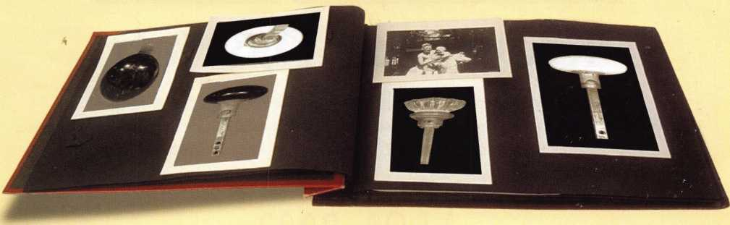

With: the LCN automatic door opener,

The Safari Safe S6140, New Year’s Resolutions

and more!

Keep Your Day Job

Come to Las Vegas and invest in your future as a security professional.

Discover classes, workshops, and exhibits that will keep you competitive in today’s marketplace,  
Las Vegas Hilton/Las Vegas Convention Center • July 14-20, 2003

The only gamble is staying home

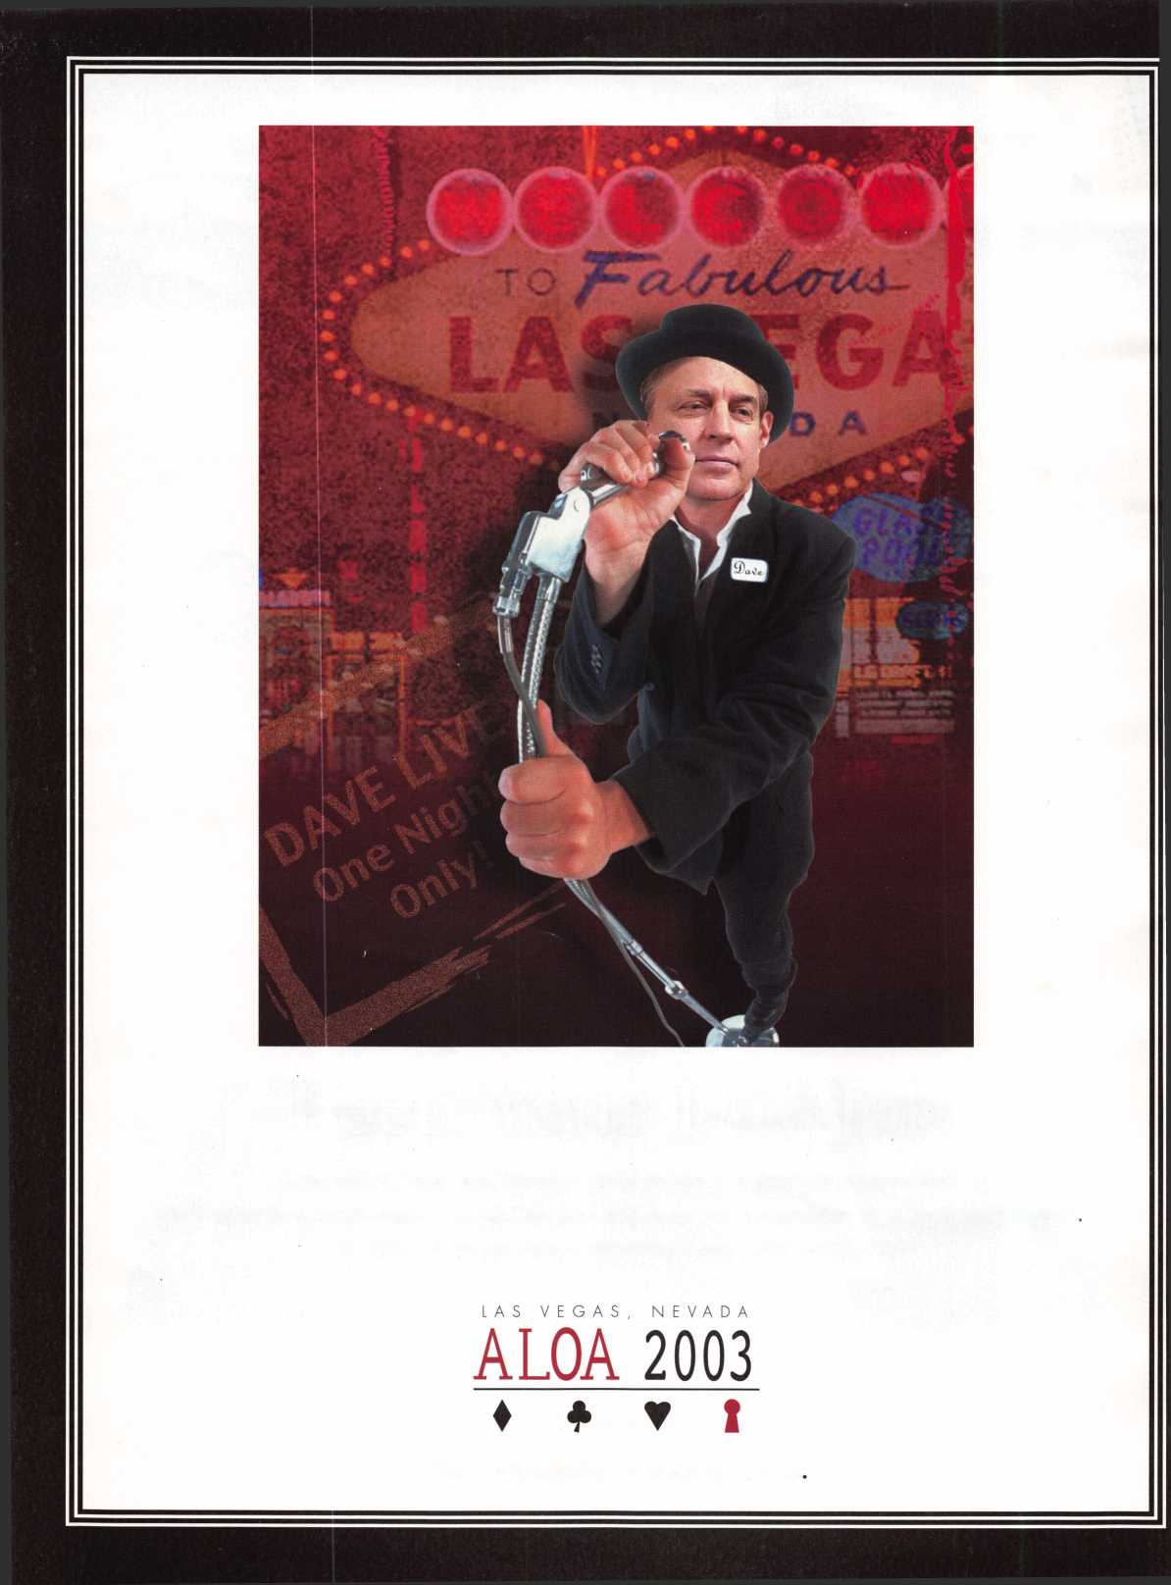

praducts **lqckSIVIITH Professionals**

**AD / ID KEY TAGS**

Specifically designed to identify the product you work with daily and promote your business with your custom Ad copy.

|  |  |
| --- | --- |
| back side of tag with 4 lines for key identificatior  KEYS FOR | 1 |
| r |
| m$ |
| SANZO-ENDICOTT, NY 13760 |
|  |  |

Clear Plastic Protective Sleeves Stock# PPS10

Protect your key tags with * 100 200 500 1000

durable plastic sleeves 11.50 19.95 42.00 68.50

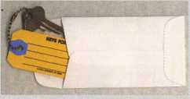

**Key Tag Envelopes**

TO ORDER: Choose QTY.,  
Key Tags with Chains or  
Rings, TAG COLOR and  
Provide Imprint Copy  
(printed black only).

ANDOVER MA 05242  
(508) 626-1 111

**Choose from Brass Plated Bead Chains or Chrome Plated Wire Rings**

**FREE Printing of Your Ad Copy on bac**

ANDOVER LOCK & KEY SERVICE

3221 LAKESIDE HWY

LAKE VIEW  
LOCKSMITH

24 Hour Service j **(845) 556-LOCK**

Stock # KTE3 Actual Size: m x AVf QUANTITIES100 200 500 1000 2000 3000 5000

Added security and finishing touch when **it** KEY TAGS with CHAINS or RINGS 32.00 42.95 83.95 115.00 195.00 269.00 395.00

presenting keys to your customers your choice of chains or rings - if not specified we ship chains

» 100 200 500 1000

10.50 17.00 37.50 65.00

**Key Tags Only** (no chains or rings) - Deduct 10% from above prices  
National Logos - No Charge / Custom Logos - Add $25.00 and supply clean B & W artwork

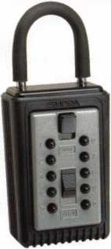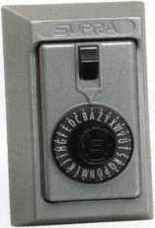

**COMBINATION KEY BOXES**

©SUPRA

**ALL METAL**

**PROFESSIONAL**

**SERIES LOCK BOXES**

®

Key Storage Lock Box

$/ALL METAL Construction

* Great Economical Pricing
* Simple to set/ Simple to open
* 5 Year Warranty

**PUSHBUTTON**

1-4 37.95 EA. / 5-9 34.95 EA.

10 or MORE 31.95 EA.

**No Home Should Be Without One**The Surface-Mount S-5 Supra  
Lockbox is a product you can provide to  
any homeowner, easily priced to your  
customer in the $50.00 range installed  
(simple 4 screw installation). Carry one

**Stock # S5-DIAL** with you at all times to demonstrate - **stock # S5-PUSHBUTTON**

Surface Mount Unit once shown it sells itself!! Surface Mount Unit

Both models now have weather resistant ALL TITANIUM METAL CONSTRUCTION with metal back and buttons. Both models are also available with PUSH BUTTON COMBINA TION LOCKS that are easy to set & reset.

**DIAL**

1-4 36.95 EA. / 5-9 33.95 10 or MORE 30.95 EA.

ShurLok has designed an all-metal key storage box that is the safest, most secure lock box on the market. Separate easy to set combinations open the shackle and key compartment — and the combinations can be changed in seconds. The ShurLok is so simple to use a child can open it, yet so versatile it will satisfy the Real Estate professional or anyone requiring key access in a lock box. Unique double combination allows all users access to key(s) while allowing only authorized users access to the shackle and will prevent lock box removal or theft.

1 to 9 $19.95 ea. Stock #SLK100R

10 or more $17.95 ea.

*if color is not specified we ship blue*

**Stock # C3-PUSHBUTTON**

Removable KeyBox, DoorGuar rubber bumper protects surfaces

**Stock #C3-DIAL**Removable KeyBox  
DoorGuard rubber bumper protects surfaces

Stock #SLK100  
Blue

**Set your own combination**

The combination can be changed in seconds —  
without special tools or disassembly. Changing  
the shackle combination also automatically changes  
the combination for the sliding key storage door.

**10,000**

Combinations

Change If ' button

Possible!

Changing the

for the shackle

only takes a few seconds

with a simple turn  
of the change button.

**\*$7.00 SHIPPING CHARGE ADDED PER ORDER** NY RESIDENTS ADD APPLICABLE SALES TAX

**SANZO SPECIALTIES, INC. TOLL FREE: 1-800-222-4041**

**BOX 68 ENDICOTT, NY 13760 FAX: 607-748-0507**

***VISA***

*Masiei*

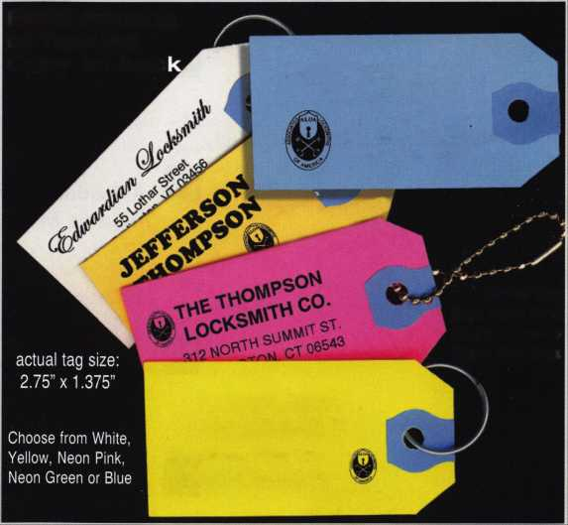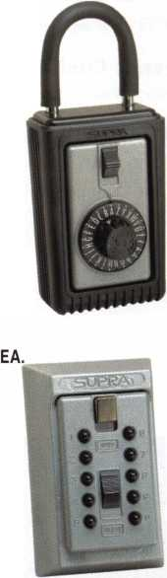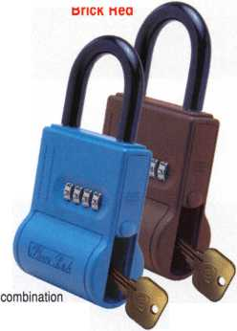

f

e

a

t

u

**res**

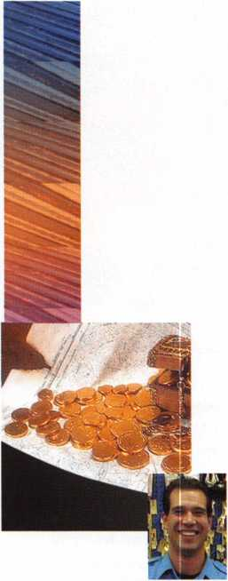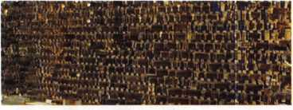

Hardware History ByMemttPerkins, *rl*

Gaining perspective by looking back. A look at some turn-of-the-century (no, not this century!) hardware and how new standards in security evolved steadily over time.



A Tradition of Excellence:

Toledo's McElheney Locksmiths bxJason k^crl

McElheney-Brungard Hardware opened in 1911 at 1505 Adams St. in Toledos Lifetime Building, under the ownership of John Brungard and William McElheney. The twists and turns associated with this company over the years is an epic of industry history.



An Open Door Policy! *bx* Greg Perry, *cml,cps*

It started with a call from the landlord who needed an automatic door opener installed at his building. I priced the job using LCN 4642 Electric Auto- Equalizers™.



Going on a Safari ByGreg Perry, CML,CPS

We recently had an industrial customer have his gun safe torched. With the clock ticking, we called to our distributor found they didn't have the same safe in stock, but they did have a Safari Safe Company S6140, which seemed to fit our needs. But who is Safari Safe Company?



The Evolution of a Unique

Rolling Keyboard (Part 2) By John Dorsey, CML, CPS, CFL

In part one of this series, the original keyboard worked nicely until it got old. It was time to design a bigger, better board. Here's how the author did it.



Success Breeds Confidence

By John Elliot, CML, CPS

Tips on a winning attitude from a locksmith who's been there, done that.



New Year: A Time to be Thankful bxc/a,re l. Cohen, cml

A New Year...2003. Let's look to the coming year in gracious terms. How privileged we are to be part of the thriving security industry. We are fortunate to be members of ALOA, an international association with resources for further­ing our education, and a way to meet others in our profession.

|  |  |  |  |  |  |  |  |  |  |
| --- | --- | --- | --- | --- | --- | --- | --- | --- | --- |
| r |  |  | d< | epartments | | |  |  |  |
| Executive | 3 | Applicants | 6 | Legislative |  | Classifieds .... | 40 | Back Page | 44 |
| Calendar | 10 | Core | 41 | Update | 38 | Associate |  |  |  |
|  |  |  |  |  |  | Members | 42 |  |  |



Visit our website at [www.aloa.org](http://www.aloa.org)

**executive**

Volume 49, Issue 1



Additional contact information for the ALOA Board and most Keynotes authors is  
available through "Locksmith Search7" on the ALOA Web site- [www.aloa.org](http://www.aloa.org) or by  
contacting the ALOA office at 3003 Live Oak Street; Dallas, TX 75204; (800)532-2562;  
FAX (214)827-1810; e-mail [aloa@aloa.org](mailto:aloa@aloa.org).

Editor

Jim DeSimone [editor@aloa.org](mailto:editor@aloa.org)

Technical Editor

David Lowell, CML, CMST [david@aloa.org](mailto:david@aloa.org)

Editorial Advisor

John D. Cannon, CML [jdcannon@worldnet.att.net](mailto:jdcannon@worldnet.att.net)

Art Director

Betty Henderson [betty@aloa.org](mailto:betty@aloa.org)

Advertising Sales

Kim Hammond voice: 817-645-6778

Fax: 817-645-7599

e-mail: [adsales@aloa.org](mailto:adsales@aloa.org)

Executive Director

Charles W. Gibson, Jr., CAE [charlie@aloa.org](mailto:charlie@aloa.org)

Convention & Meetings Manager

Kelly Carr, CMP [kelly@aloa.org](mailto:kelly@aloa.org)

PRP/Education Manager

David Lowell, CML, CMST [david@aloa.org](mailto:david@aloa.org)

Contributors

Jerome Andrews, CML  
Paul Chandler, CRL  
Claire Cohen, CML  
Brian Costley, CML, CMST  
Ray D'Adamo, CML

Sal Dulcamaro, CML Billy Edwards, CML Dan Graffeo, CRL,CMST AJ. Hoffman, CML Jeff Nunberg, CML, CMST

Operations/Membership Manager

Mary May [mary@aloa.org](mailto:mary@aloa.org)

Director of Information Technology

Randy McChristian [randy@aloa.org](mailto:randy@aloa.org)

Government Affairs Manager/

Chapters & Regional Associations Liaison

|  |  |
| --- | --- |
| Tim McMullen | [Hm@aloa.org](mailto:Hm@aloa.org) |
| Comptroller | Kathy J. Romo |
| Network Specialist | Greg Jackson |
| Membership Coordinator | Shelly Jett |
| Convention & Meetings Assistant Karen Lyons | |
| PRP/Education Coordinator | Ashley Manson |
| Accounting Coordinator | Stephanie Brothers |
| Mail Room Coordinator | Kevin Wesley |

Mike Oehlert, CPL, CPS Randy Simpson, CML Robert Stafford, CML Dave Thielen, CML Greg Perry, CML,CPS

Tom Seroogy Charles Stephenson, CPS Dennis Watanabe, CML, CMST

Mission Statement: The Associated Locksmiths of America, Inc. is dedicated to enhancing the professionalism, education and ethics among  
locksmiths and those in related sectors of the physical security industry. With approximately 10,000 members in the United States, Canada and the  
freeworld, ALOA is poised to help members obtain the knowledge, the strength, and the confidence to perform their role in the physical security field  
with pride and dignity. But it is only through active involvement and participation that ALOA can fully achieve its potential—and can help members to  
achieve theirs.

Policies: Keynotes® is the official publication of the Associated Locksmiths of America, Inc. (ALOA). Keynotes® acts as a moderator without approving,  
disapproving, or guaranteeing the validity or accuracy of any data, claim, or opinion appearing under a byline or obtained or quoted from an acknowl-  
edged source. The opinions expressed by the authors do not necessarily reflect the official views of ALOA. Also, appearance of advertisements and  
new products or service information does not constitute an endorsement of products or services featured by the Association. The Association does not  
accept responsibility for the inaccuracy of any data, claim, or opinion appearing in this publication, due to typographical errors on the part of the  
authors, Association staff or its agents.

Editor's Note: This publication is designed to provide accurate and authoritative information in regard to the subject matter covered. It is provided  
and disseminated with the understanding that the publisher is not engaged in rendering legal or other professional services. If legal advice and other  
expert assistance is required, the services of a competent professional should be sought.

Authors' Payment: Payment for eligible submissions to Keynotes will be based on the following criteria: topic, time spent and past contributions. Authors who  
regularly submit to Keynotes® are generally paid a higher rate. The latter is especially true of authors who write to fit specific editorial needs and submit said copy  
by Keynotes® deadlines. As a general guideline: Average payment for a 750 word, business or 'light' technical article would be $200. Payment for a 1500 word  
article involving significantly higher time and research efforts would be $400.

Payment will not be offered for articles submitted by ALOA employees or members of the ALOA Board of Directors (unless material is of a technical  
nature), nor for articles submitted by a company that promote that company's products or services. ALOA reserves the right not to pay for articles sub-  
mitted by an individual(s) that promote a particular company's products or services.

Disclaimer: The Associated Locksmiths of America, Inc., (ALOA), reserves the right to refuse any article for any reason. Additionally, ALOA reserves  
the right to edit, amend or modify any article submitted for publication in order to preserve technical accuracy, clarity, fairness or grammatical cor-  
rectness. ALOA will make the best efforts to notify the author of any changes. The extent of ALOA's liability for any article or information contained  
therein will be a notice of correction or retraction in the next possible issue.

Keynotes® (ISSN 0277 0792) is published monthly except for the combined June/July issue by The Associated Locksmiths of America, Inc.,  
3003 Live Oak St., Dallas, TX 75204-6186. Telephone: (214) 827-1701; FAX (214) 827-1810; e-mail [aloa@aloa.org](mailto:aloa@aloa.org). Subscription rates for  
members—$15.00 per year. Second class postage paid at Dallas, Texas. POSTMASTER: Send address changes to: Keynotes, 3003 Live Oak St.,  
Dallas, TX 75204-6186. © Copyright 1999, All rights reserved. No part of the contents may be reproduced or reprinted in any form without prior  
written permission of the publisher.

President

Randy Simpson, CML

1. 780-7026 [president@aloa.org](mailto:president@aloa.org)

Secretary

John D. Cannon, CML  
(703) 9606413  
secretary@aloa .org

Directors, Northeast

Robert E. Mock  
(215)624-5035  
[nedirector@aloa.org](mailto:nedirector@aloa.org)

Peter Sarailian, CRL  
(973)890-9797  
nedirector@aioa org

William L. Young, CML  
(610) 647-5042  
[nedirector@aloq.org](mailto:nedirector@aloq.org)

Directors, Southeast

Vincent Formon, CML, CPS  
(901) 324-2910  
sedirector@aloa .org

Donald E. Rule, CML  
(662) 324-2658  
[sedirector@aloa.org](mailto:sedirector@aloa.org)

Directors, North Central

Mark E. Blum, CML, CPS  
(517) 482-5809  
[ncdirecfor@aloa.org](mailto:ncdirecfor@aloa.org)

John Soderland, CML, CMST  
(414) 327-5625  
[ncdirector@aloa.org](mailto:ncdirector@aloa.org)

Director, South Central

CD Lipscomb, CML, CPS  
(903)874-3522  
scdirector@aloa. org

Directors, Southwest

Gordon R. Racine, CML  
(719) 384-4707  
[Swdirector@aloa.org](mailto:Swdirector@aloa.org)  
Julie McCluney, CRL

1. 636-5652 swd i recfor@a loa. org

Director, Northwest

Scott L. Henke, CRL, CPS  
(907) 248-3785  
[nwdirector@aloa.org](mailto:nwdirector@aloa.org)

Director, European

Hans Mejlshede, CML  
(453)539-3939  
[eurdirector@afoa.org](mailto:eurdirector@afoa.org)

Director, Asian

Joej. Lee, CRL  
(215)289-2404  
[asiandirector@aloa.org](mailto:asiandirector@aloa.org)

Director, Associate

Paul M. Justen  
(800)333-6953  
asdi rector@aloa. org

Trustees

[rrustees@aloa.org](mailto:rrustees@aloa.org)

JohnJ. Greenan, CML, CPS  
1773) 486.2030

Dallas Brooks  
[334)826-8990

David M. Lowell, CML, CMST  
[800)532-2562

Past Presidents

1999-2001 John Greenan, CML, CPS  
1997-1999 Dallas C. Brooks  
1995-1997 David Lowell, CML, CMST  
1993-1995 Breck Camp, CML  
1991-1993 Henry Printz, CML  
1989-1991 Evelyn Wersonick, CML, CPS  
1987-1989 Leonard Passarello, CPL  
1985-1987 Joe Jackman, CML  
1983-1985 Stanley Haney, CPL  
1981-1983 Louis LaGreco, CPL  
1979-1981 John Kerr, RL  
1977-1979 Clifford Cox, CML  
1974-1977 Charles Hetheringfon  
1972-1974 Gene Laughridge  
1970-1972 William Dutcher, RL  
1968-1970 Constant Maffey, RL  
■ 71966-1968 Harold Edelstein, RL  
1964-1966 William Meacham  
1962-1964 Robert Rackliffe, CPL  
1960-1962 Edwin Toepfer, RL  
1956-1960 Ernest Johannesen



Keynotes • January 2003

|  |  |  |  |
| --- | --- | --- | --- |
| p r e s i | d e | n 1 | 1 ' s |
| j o u | r n | e y | f |

At the start of a New Year, we're always looking forward, making plans for the coming months, imagining everything that hasn't yet taken place. This month, though, we're going to take a look back at the same time, to a different era, when locks were simple and security strategies still unpol­ished. It's a fascinating journey to look through some of the old mechani­cal locks and then think of the types of products we use today.

If you're looking for information on vintage locks, you can find some at [www.lockmuseum.com](http://www.lockmuseum.com), which is the homepage of the Lock Museum of America. There is also plenty of vintage lock information to be had by attending ACE classes, your regular chapter meetings and the ALOA conventions. The knowledge is there if you're willing to go out there and get it.

See you next month,

Randy Simpson, CML

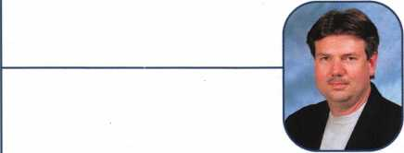

Keynotes • January 2003



*mm*

***Visit our Website on  
www. stamcctv. com***

**THE COMPLETE**

**CCTV PROGRAM ON**

**FOR STAFF TRAINING AND  
PRODUCTIVITY ENHANCEMI**

STAM Insight has been  
developed to enhance CCTV  
skills and productivity with  
many different uses.

**I#** Productivity

ft System Drawing ft Estimation **III** CCTV Training ft CCTV Reference ft Sales/Demo It System Design 11 Staff Evaluation

**14 hours**

**INFOMATE**

CCTV Content

**10 hour\***

CCTV Calculators

Demonstration Tool

Estimation

Drawing

Internet Enabled

I Pre-Test

Quizzes

Knowledge Assessment

**WORKMATE**

**ULTIMATE**

Sold in Over 50 Countries

A

Distributed by:



3003 Live Oak Street  
Dallas,Texas 75204

■ Yes, please send me a FREE PREVIEW CD ROM $9.95 S/H

Name:

Job Title:

Organization:

Address:

Zip/Postcode

e-mail

Fax: ( )

COPYRIGHT © 1996 Security Training and Marketing Pty Ltd. All rights reserved ACN 057 006 541

Country

Tel: ( )

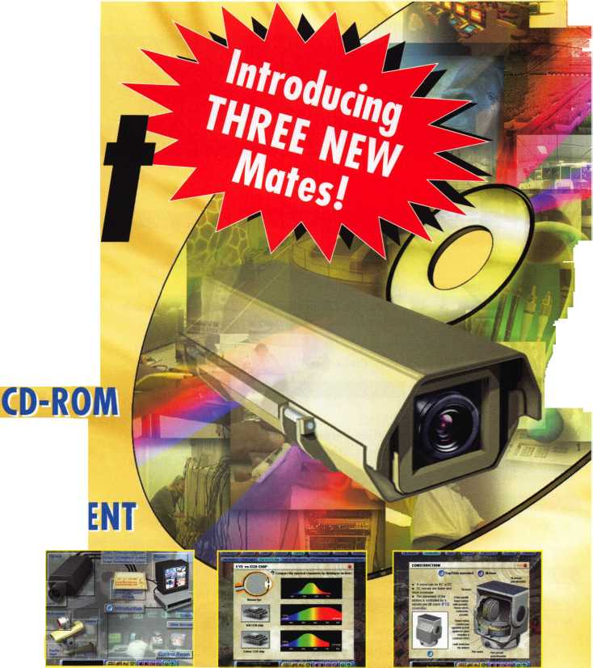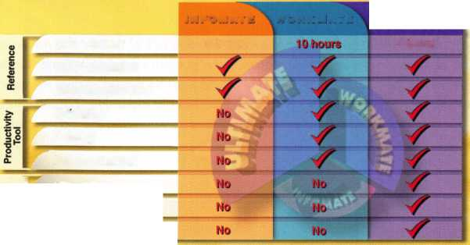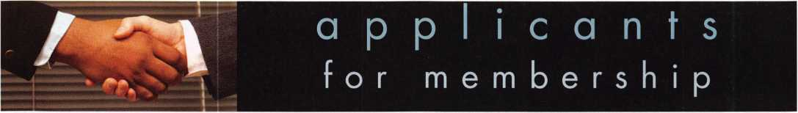

|  |  |  |  |  |  |  |
| --- | --- | --- | --- | --- | --- | --- |
| AR |  | CT |  | MA | Hurdle Mills | VA |

Bentonville

Jerry Casey

Meriden

Scott R. Cramblit

Middleboro

David Romer

Jimmy G. Wilson

Sponsor: Richard P. Boynton

Alexandria

John F. Boyd

Rogers

Kenneth W. Jordan

Springdale

Eric Casey

AZ

Mesa

Jesse B. Martin

Payson

James L Haggard

Sponsor: Robert A. Arthur RL

CA

APO-AP

Billy Abston

CO

Aurora

Kent D. Beckett

Middlefield

Steven H. Champagne

Sponsor: Lloyd Seliber CML

Ridgefield

Ken Carpenter

IL

Chicago

William Plasky

Sponsor: Barry M. Shaw CML

IN

Fort Wayne Nick A. Kelly

Sponsor: Scott B. Lininger CRL

West Lafayette

Sandra F. Amass

**LA**

Baton Rouge Richard J. Helm

Sponsor: Randall R. Jones CRL

Salisbury

Chris Whitmarsh

Waltham

Alain H. Robert

West Medford

Gordon D. Silva

ME

Bangor

Kevin S. Murray

Minot

Jayme W. French Alice C. French

MO

Lake Sherwood

Brian Mense

NC

Fayetteville

Keith E. Wilson

NE

North Platte

Melvin J. Sickler

NJ

Lakewood

Meir S. Cohen

NV

Henderson

Rick L. Miller

OK

Bartlesville

Mike E. McGrew

PA

Philadelphia

John L Winterle

TN

Newport

Hubert Willis

Arlington

Edward Mooney Jr

Charlottesville Walter Rogers

Sponsor: Eugene F. Bellomy III

Newport News

David A. Felczuk

Sponsor: David R. Goodman Sr

Woodbridge

Thomas E. Ashbrook Sr

Sponsor: Carl Rollison

Canada

ON

Orillia

Eric Lee

EBISISSsEESliHI

Culcheth Cheshire

Richard Dodsworth

These applicants are scheduled for clearance as members of ALOA. The names are published for member review and comment within  
30 days of this Keynotes issue date, respectively, to ensure applicants meet standards of ALOA's Code of Ethics. Protests, if any, should  
be addressed to the Membership Department and must be signed. Active Membership applicants (a) have worked in the industry two or  
more years. Allied Membership (AL) applicants are not locksmiths, but work in a security-related field. Apprentice Membership (AP)

applicants have worked in the industry less than two years.



**SAFE CORPORATION**

MANUFACTURES OF QUALITY DEPOSITORY SAFES AND CHESTS

DISTRIBUTING FROM WAREHOUSES IN

* LOS ANGLES**,** CA
* CHICAGO, IL
* GLASSBORO, NJ

A & B is now a stocking distributor

for Mutual Safes

featuring

uiui mg

■ I

AB-4-30-3S AB-9-2 WS 10-2

Chose from over 75 models in stock

We ship your order within

24 hours

See us

*at [www.a-bsafecorp.com](http://www.a-bsafecorp.com)*800-253-1267  
Fox 856-863-1208

CALL FOR YOUR  
CATALOG TODAY

**6**

Keynotes • January 2003

BIBmBSHI

mO|

mHI

DOORS AND HARDWARE FUNDAMENTALS

& S&

***Architectural* Doors**

*Fundarnentals Self-*

***‘ and Hard*wa**

**Study Cours**

**SELF-STUDY GUIDEBOOK**

|  |  |
| --- | --- |
|  |  |
|  |  |
|  | Ruailable as single modules (one CD and |
| W''.  V | guidebook) or the full |
| \ | set (three CDs and |
| : | three guidebooks). |
| IPV | Seruer uersions are |
|  | also auailable! |
|  |  |

**Self-Study Course**

HLOR

SPECIHL

FUNDAMENTALS OF

**Get the award-winning  
*Fundamentals of Architecture  
Doors and Hardware Self-Study  
Course* at a great price!**

The ultimate training tool for locksmiths... Noui there is a complete in-house training

**program auailable! Order the** Fundamentals of architectural Doors and Hardware Self

**Study Course** three CO/guidebook series.

To order, call (800)53

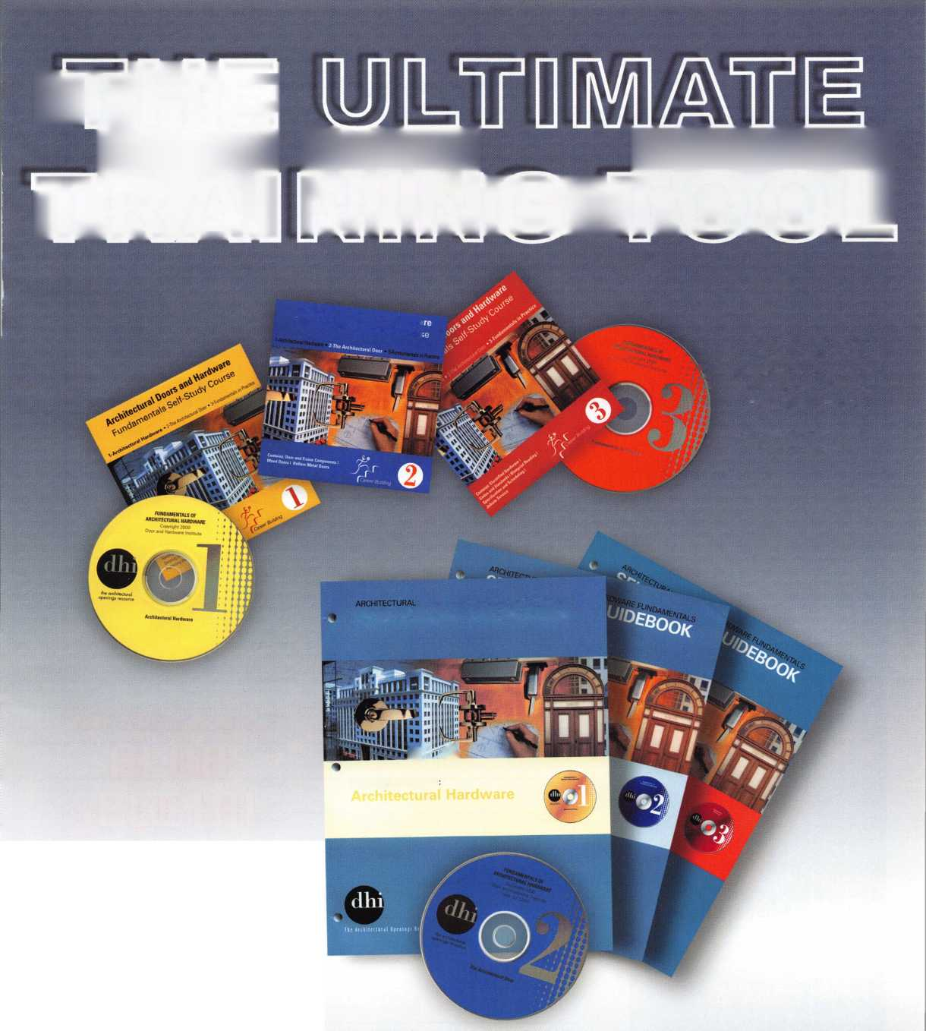

BOARD

**nominations**

**What ALOA Board Positions Are Open and Where Am I Qualified to Run?**

There are currently seven regional directors positions open for election in addition to the position of President. ALOA members now elect the directors from their own regions. Only ALOA members from a region are eligible to run for the open posi- tion(s) in that region. And only mem­bers from the nominee's region will receive a ballot to vote for that can­didate. Members from any region are eligible to run for the President position. You must have been an ALOA member for at least three years to run.

The following vacancies will exist for the election to be held before the ALOA 2003 Convention.

**President**

**Southeast two directors**

**North Central two directors**

**Southwest two directors**

If you have any questions, please contact Charles Gibson at (800) 532-2562 or email [charlie@aloa.org](mailto:charlie@aloa.org).

On this page you will find the required nomination petition and on the following page, the nomination form.

The following is the number of signatures required for each Board position:

**President 25**

**Southeast 11**

**North Central 13**

**Southwest 12**

Associated Locksmiths of America, Inc.

Board of Directors Nomination Petition

Please print legibly or type. This form can be reproduced if needed.

I, the undersigned, request that be placed on

(name of nominee and member number)

the ballot for for the election to be held at

(position for which individual is being nominated)

the special meeting of ALOA members to be held in 2003 or any adjournment thereof. I am eligible to vote in the region.



PRINTED NAME



PRINTED NAME



PRINTED NAME



PRINTED NAME



PRINTED NAME



PRINTED NAME



PRINTED NAME



PRINTED NAME



PRINTED NAME



PRINTED NAME

11

PRINTED NAME

12

PRINTED NAME



PRINTED NAME



PRINTED NAME



PRINTED NAME



PRINTED NAME



PRINTED NAME



PRINTED NAME



PRINTED NAME



PRINTED NAME

21

PRINTED NAME

22

PRINTED NAME



PRINTED NAME



PRINTED NAME



MEMBER #

MEMBER #

MEMBER #

MEMBER #

MEMBER #

MEMBER #

MEMBER #

MEMBER #

MEMBER #

MEMBER #

MEMBER #

MEMBER #

MEMBER #

MEMBER #

MEMBER #

MEMBER #

MEMBER #

MEMBER #

MEMBER #

MEMBER #

MEMBER #

MEMBER #

MEMBER #

MEMBER #

SIGNATURE

SIGNATURE

SIGNATURE

SIGNATURE

SIGNATURE

SIGNATURE

SIGNATURE

SIGNATURE

SIGNATURE

SIGNATURE

SIGNATURE

SIGNATURE

SIGNATURE

SIGNATURE

SIGNATURE

SIGNATURE

SIGNATURE

SIGNATURE

SIGNATURE

SIGNATURE

SIGNATURE

SIGNATURE

SIGNATURE

SIGNATURE

PRINTED NAME

MEMBER #

SIGNATURE

YOUR COMMITMENT TO ALOA BOARD SERVICE

(Please read carefully and sign where indicated.)

The responsibilities of an ALOA board member include contributing a moderate amount of personal time, and a significant degree of professional guidance and expertise to the organization.

You will be expected to come to board meetings and the annual membership meeting. You will need to be prepared to sensibly discuss matters of great importance to your profession and participate in setting policy as part of a governing body. Your course of action during your tenure on the ALOA board should be guided by fair minded, constructive goals pertaining to matters of consequence for ALOA and for the industry. Your contributions are expected to benefit ALOA as a whole, taking individual member rights and concerns into account, but free of the taint of partisan politics or personal gain.

On a practical note: ALOA board members are expected to behave and dress professionally at all times, especially when actively representing the association. ALOA board members are required to participate in two board meetings per year, of three or four days in length, one each fall and spring. Board members are also asked to attend the annual con­vention and are required to attend the annual membership meeting. Board members may also be asked on a voluntary basis, to represent ALOA at related local, state or regional functions, including serving in the ALOA Booth and otherwise promoting ALOA. When travel is required for a board member, expenses covered by ALOA include lodging, travel and a reasonable per **diem.** The Board has stipulated that assigned travel will be reimbursed at the lesser of the 30-day advance tourist class airfare in effect at the time of travel or the current per-mile rate for travel by personal automobile. Spouse expenses, including extra room charges, etc., are the individual's responsibility.

• • •

I have read and understand the above responsibilities of an ALOA board member, and agree to commit my time and energies as needed. I certify all of the information contained on this form and supporting documentation to be true and complete.

I can be contacted with questions at:

Address Phone #

Signed:

Date

Please attach a recent photograph of yourself and retain a copy of this profile for your own files. This profile and all supporting documentation should be submitted no later than March 1, 2003:

Mail to:

Nominee Profile

Secretary of the Board of Directors  
Associated Locksmiths of America, Inc.

3003 Live Oak Street  
Dallas, TX 75204-6186  
1-800-532-2562

**MAR I FEB JAN**

**upcoming**

19-22 Texas Locksmith Association  
40th Annual Convention  
and Tradeshow  
San Antonio, TX  
Butch Titus 210-649-2166

|  |  |  |  |
| --- | --- | --- | --- |
| 10-12 Wyoming Locksmith Association | 11 Wyoming Locksmith Association | 11 Greater Houston Locksmith Assn. | 15 Grand Canyon Chapter of ALOA |
| Winter Meeting and Tradeshow | Annual Banquet • 6:30pm | Banquet and Officer Installation | Chili Cook-Up Fundraiser |
| w/Electronic Safe Locking Class | Bryan (307) 234-3308 | Houston, TX | David Louie 480-967-8568 |
| Gene Ficek (605) 642-4542 |  | Judy Clifford [anchor@swbell.net](mailto:anchor@swbell.net) 979-297-2413 | •  ■■■* ■■■■■■■■■I |



UPCOMING PRP SITTINGS

Jan. 10 ALOA • Dallas, TX • Ashley Manson 800-532-2562, ext. 30

Feb. 14 ALOA • Dallas, TX • Ashley Manson 800-532-2562, ext. 30

Mar. 2 Minnesota Chapter of ALOA Maplewood, MN Dana Lee, CML • 612-968-4500

Mar. 14 ALOA • Dallas, TX • Ashley Manson 800-532-2562, ext. 30

April 5 MLANJ • Somerset, NJ • Dan McGlynn 973-267-8884

April 6 Clark Security Products • Chicago, IL Joan Emrick • 619-718-7308

April 11 ALOA • Dallas, TX • Ashley Manson 800-532-2562, ext. 30

April 26 Colorado Front Range Chapter of ALOA Denver, CO • Gordon Racine, CML 719-384-4707

May 9 ALOA • Dallas, TX • Ashley Manson 800-532-2562, ext. 30

June 13 ALOA • Dallas, TX • Ashley Manson 800-532-2562, ext. 30

June 22 Clark Security Products • Reno, NV Joan Emrick • 619-718-7308

July 1 1 ALOA • Dallas, TX • Ashley Manson 800-532-2562, ext. 30

August 8 ALOA • Dallas, TX • Ashley Manson 800-532-2562, ext. 30

Sept. 12 ALOA • Dallas, TX • Ashley Manson 800-532-2562, ext. 30

UPCOMING ACE CLASSES

Jan. 11 Wyoming Locksmiths Association

Casper, WY • Investigative Locksmithing I Gener Ficek, CPL • 605-642-4542

Feb.

22-23 Alabama Locksmiths Assn.

Basic Electricity and Intro to Access Control Amanda Floyd • 334-793-5060

Feb 28 -

Mar. 1 Minnesota Chapter of ALOA

Maplewood, MN • Dana Lee, CML 612-722-9181 •[Ill7@qwest.net](mailto:Ill7@qwest.net) Comprehensive 1C I & II (2 days)

Servicing Aluminum Storefront Doors Life Safety Codes and ADA

Mar. 3-7 Fox Valley Technical College • Appleton, Wl Jerry Antoon: 920-735-2406 [www.fvtc.edu](http://www.fvtc.edu) • See ad facing page

March

24-28 SAVTA (see ad inside back cover)

David Lowell, CML, CMST 800-532-2562 x!8

April 3-6 MLANJ • Somerset, NJ • Dan McGlynn 973-267-8884 • [www.mlanj.org](http://www.mlanj.org) 1 8 ACE Classes

April

24-26 Colorado Front Range • 9 Classes

719-384-4707 • [www.radisson.com/](http://www.radisson.com/) security educationweekend

May

17-1 8 Alabama Locksmiths Assoc

Birmingham, AL • Import Automotive I & II

July

14-18 ALOA 2003 (see ad page 1)

David Lowell, CML, CMST 800-532-2562 xl8

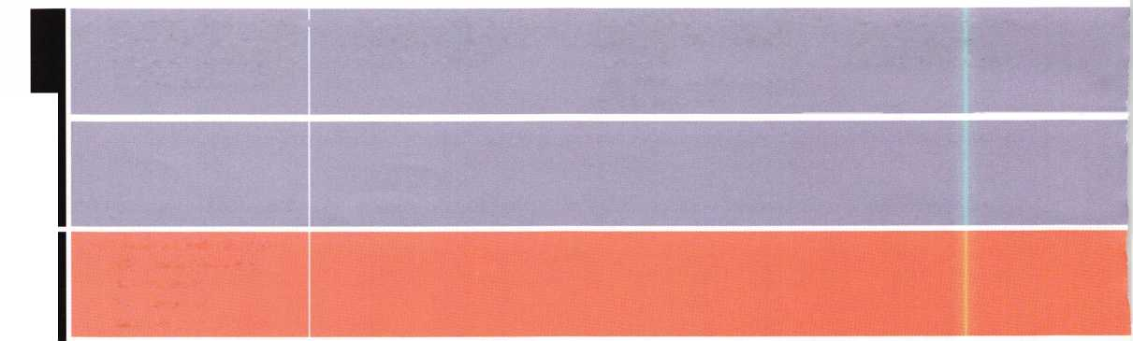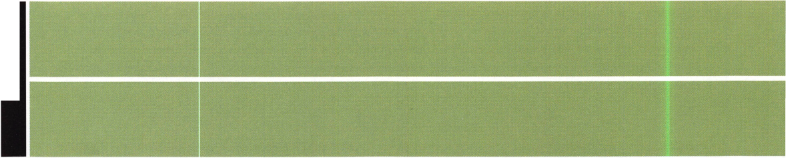

**events**

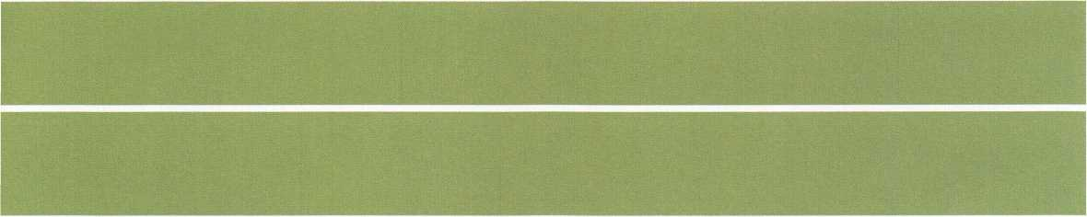

Locksmith Training

Sponsored by Fox Valley Technical College • 1825 N. Bluemound Dr. • Appleton, Wl 54912-2277

6-Day Program • Career Change in One Week • March 3-7, 2003

This is a basic locksmithing training course sponsored by FVTC’s Security and Crime Prevention  
Department and conducted by ALOA ACE instructors. Designed for the locksmith shop owner  
who would like to provide entry-level training for new apprentice locksmiths as well as those who

would like to receive professional training that will enable employment with a professional locksmith. The course will allow the student  
to gain enough knowledge to make them a starting apprentice in an existing shop. Job placement locations will be made available at the  
time of the class.

To maintain quality the course enrollment will be capped at 12 students. Enroll early!

Curriculum includes:

Key Blank Identification and Duplication Lockset Servicing, Functions, Finishes Pin and Disc Cylinder Servicing Door Closers

Key Codes and Code Equipment Life Safety Codes ^ lmPress'on'ng Lockset Installation

Basic Master Keying Lock Pick Opening Techniques Bypass Techniques Cabinet, Furniture, Mailbox Locks

Exit Flardware

All tools and equipment will be made available for use during training.

Class Flours: 8:30 am to 5:00 pm every day  
Class Attire: Shop clothes  
Course Tuition: $995.00



Course Enrollment: See Susan Egnoski in the Criminal Justice Center

or call 920-831-4393

Note: Enrollment deadline is Friday, September 20, 2002

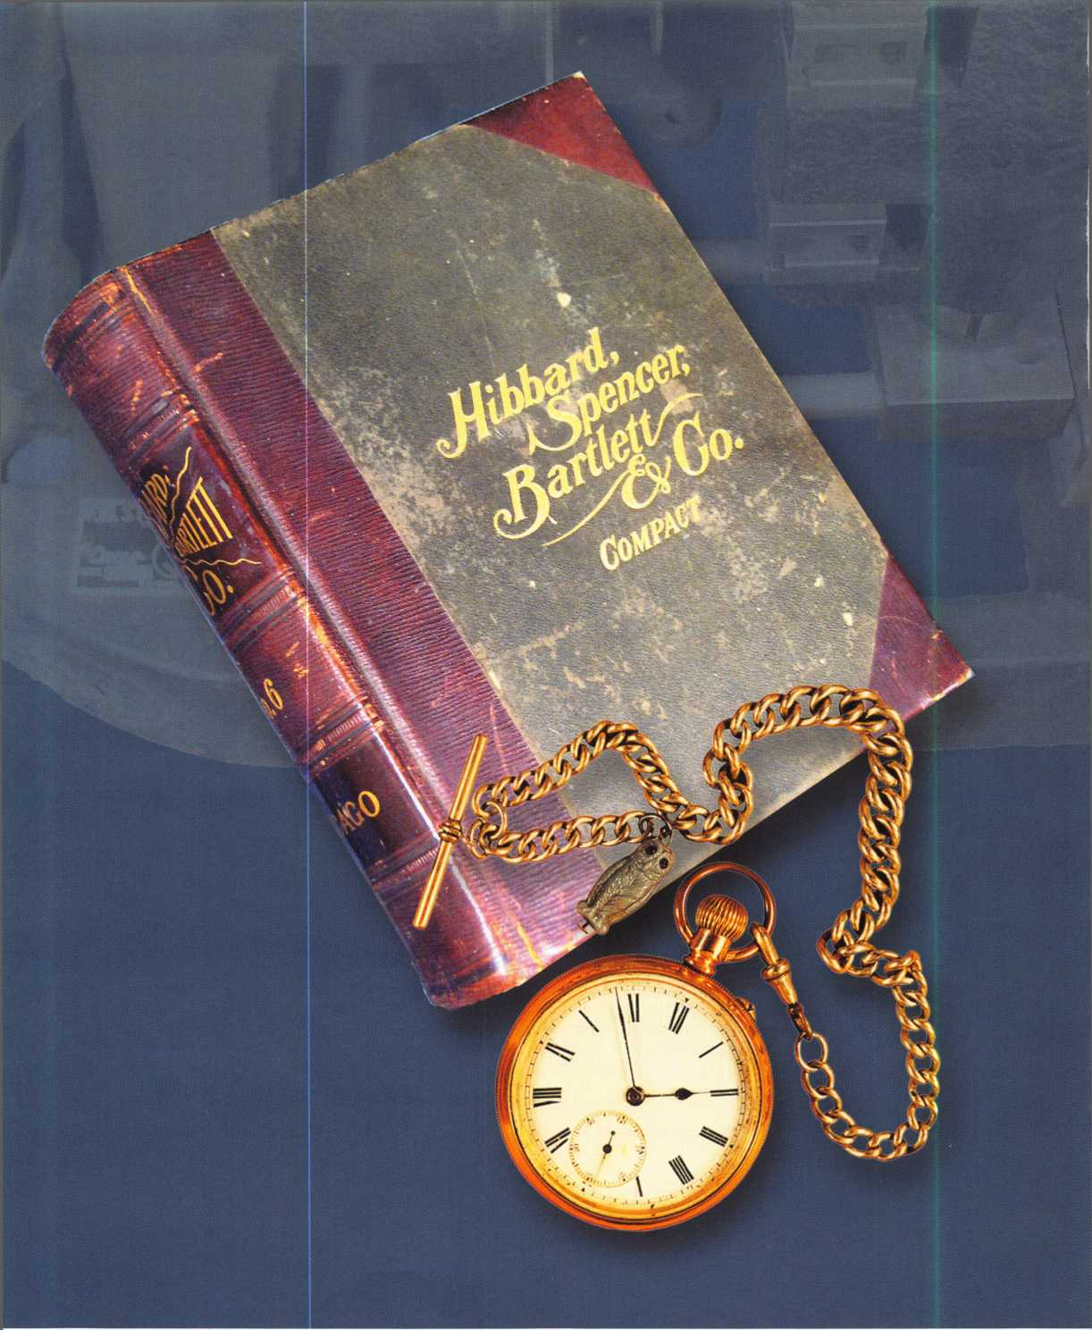

i

Keynotes • January 2003

**2**

Hardware History:

Knowledge Locked in Time ...

By Merritt Perkins, RL

My grandmother told me that when she was young, “The latch string is always out” was a common expres­sion. A wood bar pivoted at one end and extended beyond the edge of the door into the notch in a keep­er on the door frame. The bar, or latch, had to be lift­ed out of the notch to permit the door to open.

A string, which was attached to the latch, was put through a hole in the door above the latch to permit the latch to be raised from outside. To lock the door, the string was pulled.

Life in those days was very different from what is today. People heated their houses and did their cooking with open fireplaces. They had to keep the fire burning, because it was difficult to start a fire before matches were available.

They would get burning coals from a neighbor.

A rain barrel caught water from the roof and they leached wood ashes to make lye to mix with grease saved from cooking in order to make soft soap. Tallow was saved to make tallow candles before the days of kerosene lamps.

In the 1830s, Henry Wadsworth Longfellow and Mrs. Craigie lived in the Craigie house. The farmer’s wife, Miriam, furnished their meals at high prices. Miriam was very religious and always talking about the future, so she was often referred to as “Miriam the Prophetess.” When they wanted a meal, they could pull on a wire in

their room and it would ring a bell in the kitchen.

In those days, wealthy people

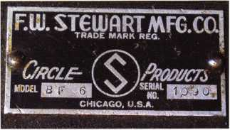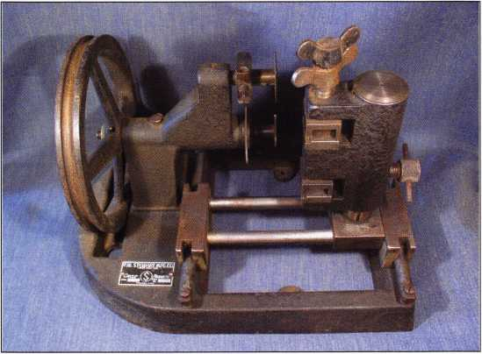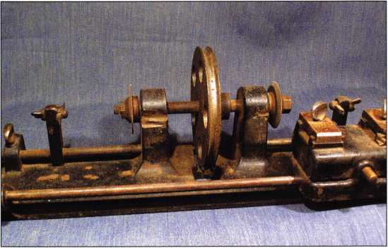

Keynotes • January 2003

lived in large houses and had servants and there are numerous references in literature of ringing for the servants. The servants usually had individual rooms on the second floor and the doors were usually fitted with warded bit key mortise locks. A skeleton key would open any of those doors.

In a large manor house, the Butler had his rooms on the third floor. The Butler ran the house, and had charge of the other servants.

There were mechanical doorbells that could be installed on the front door so that turning a knob (or pushing a button) would make the clapper strike the bell several times. One bell could be wound up by turning the bell so that pushing a button on the out­side would cause the bell to ring like an electric bell as it unwound.

Shocking Changes

With the coming of electricity, battery-operated bells came into use. Photograph i shows an annunciator with six arrows to show where the calls came from and a buzzer to attract attention. When activated, the arrow rotates 90 degrees from vertical to horizon­tal and stays in that position until reset by pulling a button on the bottom of the case.

I have an extensive, 1550-page compact hardware cat­alog dated January 1,1899 from Hibbard Spencer Bartlett & Co., Chicago (photo 2). They offer to exchange it for their full-size catalog, which weighs nearly 17 pounds. Many things in the catalog are the same as we find in a hardware store today while oth­ers were forgotten long ago.

Nicholson’s, Disston”s and New American pattern files are listed in the catalog priced by the dozen: Mill Bastard 4-inch $2.20, 8-inch $4.20,12-inch $5.60 and 16-inch $11, Warding Bastard 3-inch $3, 5-inch $3.30, Needle files, 5-1/2 inch $1.10. Seven pages are devoted to files. The files available then were the same as

those available today. Steel hand stamps - both machine made and hand made - were available in several sizes. Machine screw threads were not yet standardized. Their dies cut 1/2 inch to a foot. Extra taper taps were available with several thread pitches, for example: 1/2 inch diameter 10,12,14, and 16 right hand, 12 and 14 left hand, $0.40 each

Straight shank twist drills were available in fractional sizes from a 1/16-inch in steps of 1/64-inch and Stubs steel wire gauge sizes 1 through 60. These are the same sizes that are in common use today, but they were made of carbon steel because high speed steel had not been invented yet. There were also square bit stock drills for use in a brace, auger bits for drilling wood and gimlet bits that come almost to a point and are also used on wood. Some 56 pages are devoted to bicycles and accessories. An acetylene bicycle lamp that would throw light 100 feet ahead and 50 feet wide cost $3. Carbide cost $.15 for one pound, $.50 for 5 pounds. Prices were very different from what they are today in 1899, when men working at hard labor were paid 50 cents per 12-hour day and worked 6 or 7 days a week. Prices were so low that farmers burned corn in their stoves for fuel and worked on the roads to pay their taxes.

Imagine buying a latch for your back door for 7 cents including the screws, 5 cents without the screws. The latch was a simple pitcher handle and thumb piece on the outside with a tailpiece extending through the door and bent down to act as the handle. It was made from black Japan cast iron. It raised a latch bar on the inside. A cam attached to a lever could be turned to hold the latch bar down so that it could not be raised. It was attached with 8 wood screws.

The case and most of the parts of the bit key mortise and rim locks used on houses were usually made of cast iron. They usually had a latch bolt operated by doorknob from either side of the door and a dead bolt operated by a key from either side of the door.

**14**

Keynotes • January 2003

If there was a keyway ward there would be as many different case castings as there were positions for the keyway ward. The side ward was usually only on the case cover and there would need to be as many case covers as the positions of the side ward multiplied by the positions of the keyway ward, which would be equal to the number of key changes. The ward on the case cover may be only on the unlocking side of the keyway allowing a key that does not pass the ward to extend the dead bolt, but not to be removed with the bolt extended, or the ward may be on both sides of the keyway.

Lever tumblers were added to bit key locks to get more key changes than were provided by the number of ward combinations. Simple warded locks were often used on the back door and the key left in the lock on the inside. To prevent someone from entering with a key from the outside, a piece of wire was bent to go over the shank of the doorknob and both ends put through the hole in the bow of the key to prevent it being turned and pushed out of the door.

More complicated entrance locks were usually used on the front door. Some of these had a split spindle so that push buttons or a lever in the edge of the door could lock or unlock the outside knob while leaving the inside knob free to retract the latch bolt. A key from the outside could retract both the dead bolt and the latch bolt.

Another model had two key holes from the outside, one to retract the dead bolt and the other to retract the latch bolt. There was a thumb turn on the inside.

Early door knobs were white porcelain or earthenware and had a cast-iron shank with a 9/32 inch square hole for the spindle which was held in place by a 9-24 x 3/8 in oval head machine screw. The shank was held in place in the hole in the knob with lead. The lead tended to work loose after a few years of use and the knob would come off. Later, knobs were usually made of steel. The simpler bit key locks had six or twelve changes.

Inside bit key mortise lock sets with one key were as little as $6.50 per dozen, with cast front and strike, $12.50 per dozen with bronze bolts, front and strike. Front door sets with bronze bolt, front and striking plate, old copper finish, bronze metal escutcheon and knob, swivel spindle, 2 keys for the night latch and one key for the lock bolt $2 per set.

A hardware store would have a large keyboard to dis­play the keys for locks in use in the area. Malleable iron keys were $3.50 per gross of assorted keys for a given model of lock. Steel keys and blanks were $1.50 per dozen. The ward cuts would be made with ward­ing files. Yale flat steel pin tumbler keys were $.30 per dozen, No. 6 corrugated blanks $1 per dozen and No.

8 paracentric blanks $3 per dozen, A large steel key that folded up like a jackknife used on store door rim locks was $4.50 per dozen. Q

Early door knobs were white porcelain or earthenware and had a cast-iron shank with a 9/32 inch square hole for the spindle which was held in place by a 9-24 x 3/8 in oval head machine screw

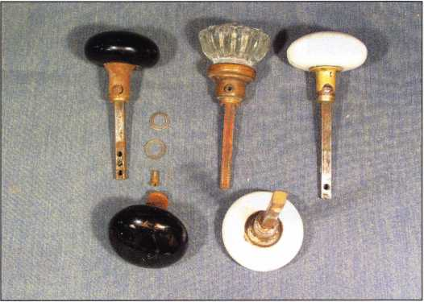

Keynotes • January 2003

A Tradition of Excellence:

Toledo’s McElheney Locksmiths

By Jason Koler, CRL

At 7:30 a.m., William J. McElheney II answers a call from one  
of his locksmiths over the two-way radio. The store doesn’t  
open for another hour, but he already has two service vans on  
the road, completing early morning emergencies. A woman has  
locked both her keys and baby in the car, and Bill Jr., reassures  
her that one of his trucks is en route. His desk sits in one cor-  
ner of an office that he shares with his father, William J.  
McElheney, who is vacationing in Florida. “He hadn’t taken a  
vacation in 40 years, can you believe it?” Looking around the

office lined with family photos, one can only guess at the amount of work involved in  
building one of the largest locksmith companies in the Mid-West.

McElheney-Brungard Hardware opened in 1911 at 1505 Adams St. in the Lifetime Building, under the ownership of John Brungard and William McElheney. William bought out his partner in 1929, and in 1950 McElheney Hardware moved across the street into 1512 Adams. William’s son Robert bought the company in 1956, and the fol­lowing year his son, William entered the family business after his discharge from the army. Stationed in Germany during the Hungarian uprising, William returned home, and began stressing the locksmithing aspect of the business, and the need for a phone book ad, “after going from one or two service calls a day, the ad really did well for us, and we soon hired and trained three full time locksmiths.”

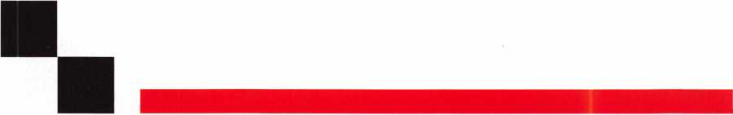

**6**

Keynotes • January 2003

Now McElheney Locksmiths, located at 1214 Jefferson  
Ave., averages 40 calls a day, providing service from  
Indiana to Cleveland and Cincinnati. The McElheney  
fleet consists of five service vans, a car for running  
parts, and a truck and trailer for delivering safes and  
ATM’s. Often the vans are out of the store by 7:30  
p.m., and do not return until all the work promised  
for the day is complete. “We are in a business that  
provides peace of mind, ... and our customers rely on  
us to be there whenever the need arises.” To ensure  
their customers receive the best service possible,  
McElheney’s have a service tech on call 24 hours a  
day, 365 days a year. And the store has closed so few  
times that William Sr. has no problem recollecting  
those rare days.

“When President Kennedy was shot,” said Bill Jr., “my  
father closed the store to mourn with the rest of the  
country.” During the blizzard of‘78 Mother Nature  
buried the store under several feet of snow, and Bill  
Sr. delivered two employees for an emergency lock  
down. The fourth generation of McElheney’s are cut-  
ting keys and the business has come a long way tech-  
nologically, but still retains the business philosophies  
started in 1911. Customer satisfaction is priority num-  
ber one, while a clean cut staff and tidy showroom tie  
a close second. The lessons in the family business did

not pass through lectures and notes, but

from working long hours and observing  
how the previous generation handled  
customers like a pieces of gold.

In 1972, Bill Sr. bought the company  
from his father, and moved the business  
down the street into a building at  
Adams and 13th. Soon his brothers,

Robert and Ray, purchased their own hardware stores  
with locations on Airport Highway, and Bennet Road,  
respectively. In the coming years, family-owned hard-  
ware stores faced growing competition from national  
chains such as Handy Andy and Home Depot, and  
Bill Sr. sensed the shift and decided against fighting  
the huge conglomerates, focusing his attention on  
lock work.

While at Adam and 13th, the Toledo Police and Fire  
Departments went on strike, causing pandemonium

and concern through-  
out the city. One of  
these mornings, a fire  
started across the  
street, destroying  
three buildings, the

heat shatter-

ing

McElheney’s  
storefront  
windows.

Because of  
the down-  
town loca-  
tion, the  
McElheney

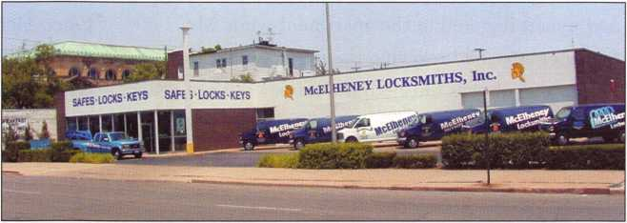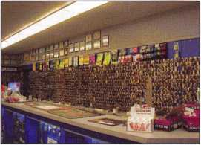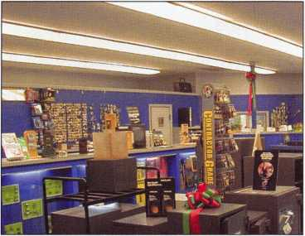

Keynotes • January 2003

family has witnessed many of the cities most devastat­ing blazes, such as the Tiedtke fire of 1975.

“During the race riots of the sixties, Molotov cock­tails were finding their way into local business, so my father had me stack bags of fertilizer in the windows,” said Bill Jr.

Now on Jefferson Ave., the store has faced bomb threats intended for the neighboring Lucas Co. Treatment Facility, and Planned Parenthood, which stands directly across the street. As a locksmith, dan­ger comes with the job. Regardless of time or weather, technicians must enter any neighborhood. McElheney Locksmiths are also on the Police’s calling list for opening safes during raids and seizures. Sometimes, the safes are booby trapped with tear gas or other devices, and the locksmith must be mentally primed for all situations. However, no amount of safety could have prepared Bill Sr. for what seemed like a typical day in 1978.

One afternoon Bill Sr. received a call from the manag­er of the Hillcrest Hotel on 16th Street, explaining one of his employees was involved in an accident. A man occupying a penthouse suite of the Hotel noticed coins and other valuables missing, and suspected and ‘inside job’ was taking place. Bill Sr. dispatched a “gen­tle giant” of a man, Paul Smothers to the man’s apart­ment. Around lunchtime the executive housekeeper and tenant lingered in the apartment while Mr. Smothers finished rekeying the locks. Sometime before the job was finished, the robber returned, star­tling himself and the three men. The perpetrator then

forced the three into the bathroom and shot them all point blank in the back of the head. The assailant, a cook in the hotel, was apprehended within hours, but McElheney still carries the burden of losing one of their most valued employees.

Slowly business resumed to normalcy, and within a year, McElheney Locksmiths secured an account guar­antying their success. Ohio Bell was experiencing problems with key control. Over the years, their employees had duplicated so many keys that the secu­rity of the building became compromised. William suggested they implement a new lock system called Medeco to combat unrestricted duplication. The Medeco line of locks and keys are covered under U.S. patent laws, so every single Medeco key leaving the store must be signed for by an authorized cardholder. The Medeco brand of locks is still one of McElheney’s biggest sellers and his customer some­times do not even realize the seriousness that he undertakes with his policy.

“The president of a company that recently installed a Medeco system neglected to fill out his individual sig­nature card,” said Bill. “He came in to replace a key and we could not issue one to him because of his oversight. His annoyance at an inconvenience turned into gratitude when he understood the thoroughness of this system.”

Once McElheney’s obtained the Ohio Bell account, other companies such as banks, industries, and schools filed suit and McElheney Locksmiths entered their most prosperous era. Bill Sr. and his son moved

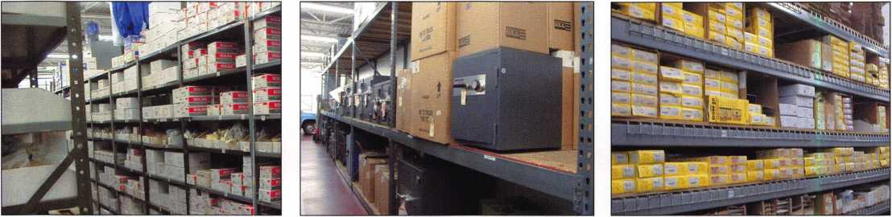

**8**

Keynotes • January 2003

the Adams St. store to 1214 Jefferson Ave. in 1991, and  
within one year, their walk-in business doubled, and  
continually expands every year. After the Americans  
with Disabilities Act (ADA) was passed by Congress,  
the company once again faced an industry change.

The door hardware market began introducing prod-  
ucts for people with

special needs.

“The lock industry  
is always changing,  
we’re constantly  
trying to keep one  
step ahead of the  
crooks,” Bill said.

Along with ADA  
hardware, William  
also added ADA  
signage. Now  
McElheney  
Locksmiths encom-

passes an engraving department run by a full time  
engraver, whose skills appear on elegant wedding bot-  
tles, glass plaques, and plastic signs.

Along with the engraver, bookkeeper, dispatcher, and part-time custodian, McElheney rounds out their staff with nine full time locksmiths, including Bill Sr.’s youngest son, Michael. This makes them one of the largest locksmith service companies in the country, and Bill Jr. eagerly comments on the skills of his employees. Each is a bonded locksmith, fully trained in servicing the simplest lock as well as the latest elec­tronic devices. Several of McElheney’s employees have earned national certification through industry testing, and frequently attend locksmith workshops and class­es. In 1997, McElheney hosted an open house for

regional locksmiths interested in viewing other com-  
panies operation.

“The visiting locksmiths were in awe of our inventory,  
and some even told me how I inspired them to push  
their business in different directions,” Bill said.

“When I first started in the business, tricks of the

trade were like guard-  
ed secrets. Now with  
the Internet and  
organizations like  
ALOA, information is  
readily available for  
those who aspire to  
become a professional  
locksmith.”

McElheney  
Locksmiths repre-  
sents decades of  
involvement in the  
community by donat-

ing time and money into projects like the race for  
Junior Achievement, the Distinguished Clown Corps,  
and providing security presentations when the  
Sheriff’s Department sets up Block Watch programs  
around town. Last spring, Bill Jr. drove a limousine for  
the Presidential motorcade through the Glass City.

Bill Sr. is a member of Toledo’s Rotary club, and his wife, Joanne spends countless hours involved in civic minded charities. McElheney has been a trusted name in the security industry for almost 100 years, and Mr. McElheney prides himself on customer appreciation. “I enjoy hearing customers’ memories of visiting the hardware store with their father or grandfather. I’m proud the McElheney name has become a fixture in Toledo.” □

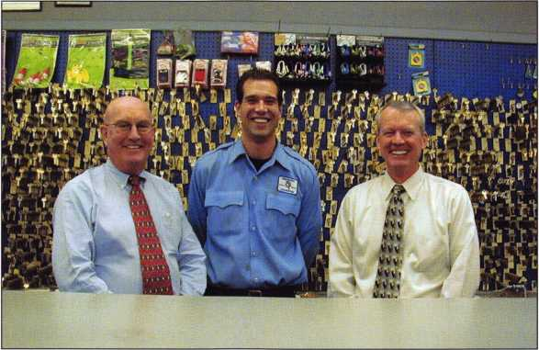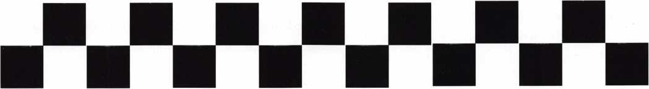

Keynotes • January 2003

An Open Door Policy

By Greg Perry CML, CPS

This job started with a call from the landlord. He was rebuilding the interior of a strip mall to accommodate an employment office. The landlord had us install an alarm system, panic devices, door closers and they wanted a couple of automatic doors as well. After informing them that we’re not in the automatic door business, they asked what we could provide to make the door accessible to the handicapped. Some type of power-assisted opener was needed. Now they’re ask­ing for something we can provide. I priced the job using LCN 4642 Electric Auto-Equalizers(tm). They opted for one door after hearing the price.

LCN offers two different versions of Electric Auto- Equalizer(tm): the 4642 for push side mounting, and the 4631 for pull side mounting. They also offer a pneumatic version. The pneumatic requires an air compressor that would also require 120-volt AC power, so unless compressed air is readily available, use the electric version.

We started by removing the old Norton closer and drop plate. The header was coming loose from the frame. Rather than try and reattach the header, we decided to provide a better mounting surface. A 3/16” x 6” piece of aluminum was cut to size and fastened to the header and frame uprights. Both screws with nut- serts and rivets were used to fasten the mounting plate. Using rivets complements the strength of the screws by helping to provide some rigidity to the assembly. We now have a great surface for mounting the door operator.

The unit comes in 5 major pieces; the mounting base, the closer, the arm, the electronic controller and the cover. The mounting base also houses some circuit boards with terminal blocks and the motor is installed

first. Although you can measure and drill all the holes first, we prefer to drill and tap one hole, attach the base with this one screw and mark the balance of the screw holes. Remove the base drill and tap the bal­ance of the holes before installing the base. Next, install the electrical. Most if not all jurisdiction, require all 120-volt electrical wiring to be performed by a licensed electrician. Our electrician left a junc­tion box just above the drop ceiling. We used some flexible conduit with the wire preinstalled to run inside the wall, then down through a square aluminum tube to conceal it. The side of the tube was cut or slotted at the bottom for exit to the top of the opera­tor. The wires were attached to the correct terminals on the operator terminal block. In addition to the high voltage-wiring, low-voltage switch circuits are needed to control the operator. A wireless receiver was installed in the overhead to provide the switch­ing. The low voltage wiring was run down the other side along with the alarm wiring. Two wireless push­buttons, one inside, one out were installed. If the need should arise later, a third button could be installed at the reception desk. The instructions pro­vide for many different switching circuits depending on requirements. An example of a different applica­tion is for a double door vestibule entry where only one door should be open at a time.

Next to be installed is the closer body. First the power was adjusted to match the door. It looks very similar to a 4041 door closer, only with a tube at both ends. The door was then drilled and tapped at the appropri­ate locations for the arm. A spindle extension was added, and the arm installed both to the operator and the door. The closer was adjusted the same as the

**20**

Keynotes • January 2003

4041 closer, backcheck, sweep and latch. Once the door was closing at the proper speeds the electronic control module was installed over the top of the clos­er body. The motor cable was plugged into the con­troller. Next, the ribbon cable was installed from the circuit boards to the control module. With everything in place but the cover, power was applied. Not seeing any smoke, we tested the unit. Pushing either button resulted in the door opening. The cover was installed - almost completing this install.

Since this is an exterior door, we decided to add a control circuit from the alarm panel to prevent switches from sending the signal to the operator when the alarm is set. This involved adding a relay in the wiring from the wireless receiver controlled by the alarm panel. LCN designed the closer with a very low opening force; it also has a clutch built in to prevent damage if the opener should encounter a stop. The addition of the relay is not needed, but we felt since lots of kids play in this center, we wanted to provide a positive disconnect. Another benefit to this clutch system is that a safety rail or bar to prevent the door from opening onto someone is not required.

Installing this operator took the better part of a day including all the wiring. The labor portion of the job billed at $1000. The next time it should take a little less, perhaps even two a day if they were close to each other. We’ve found some of the most profitable jobs are the ones others are unwilling to even attempt. Q

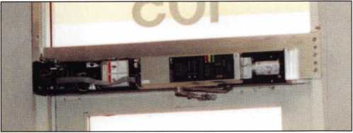

1. The aluminum tube housing the conduit is visible in the left  
side of the frame.

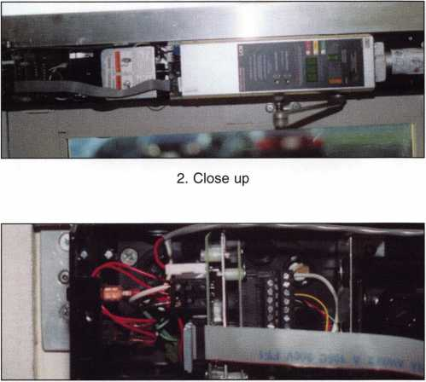

3. This is where all the external wiring comes in and ties  
onto the operator.

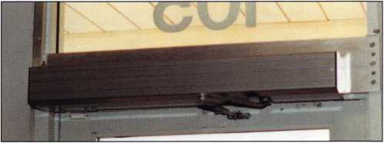

4. The cover is now installed.

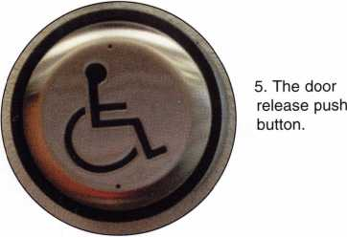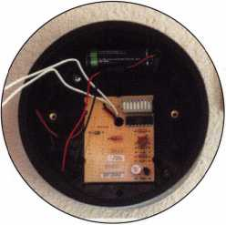

6. This is the inside of the push button assembly. The circuit board is the transmitter.

Keynotes • January 2003



**RING of a KING**

|  |  |  |  |
| --- | --- | --- | --- |
| Name | Members | James L. Hancock CRL | 17 |
|  | Recruited | Joseph P. Ferrero CML | 16 |
| Kwok-kei Leung | 212 | Gary F. Teams CPL | 16 |
| Henry W. Raymond | 100 | Kenneth E. Kim CRL, CPS | 16 |
| Yuriko Yanai | 77 | Joseph W. Whitaker CPL | 16 |
| Mary S. Ohmit CPL | 66 | Michael E. Jordan Jr, CML | 16 |
| Charles C. Robertson CML | 65 | Brian J. Reetz | 16 |
| Jack Hobin CPL | 51 | Russell P. Fuller CRL | 16 |
| William B. Neff CML | 48 | David M. Troiano | 16 |
| Salvatore J. Dulcamaro CML | 40 | Robert C. Rodocker CPL | 15 |
| C Allan Halverson | 38 | Ernest W. Wright | 15 |
| Myeong-Rae Cho | 38 | William J. McElheney CML | 15 |
| William Lee CRL | 37 | Jon B. Griswold CML | 15 |
| Dana L. Barnum CML | 35 | Michael D. Robinson CRL | 15 |
| Barry K. Leas CRL | 35 | John A. Ilk CRL, CPS | 15 |
| Danny W. Rudd CPL | 32 | Daniel L. Landry Jr | 15 |
| Michael B. Groves | 32 | Steve L. Cothron | 15 |
| Larry A. Warnick CML | 31 | Leonard J. Passarello CPL | 14 |
| Jim Williams CRL | 31 | Paul M. Souber | 14 |
| Jeanne G. Lodge CML | 30 | James T. Brickler CRL. | 14 |
| Eugene R. Altobella Sr | 30 | Joseph C. Fuller CML, CMST | 13 |
| John C. Elliott Jr, CML, CPS | 28 | Calvin G. Harris CML | 13 |
| Robert D. DeWeese CML | 28 | Peter Sarailian CRL | 13 |
| Lawrence F. Smith Jr, CML | 27 | Frank D. Hartung CML | 13 |
| James M. Watt CML, CPS | 27 | Rolando Bouza | 13 |
| Anthony J. Ramunno CML, CPS | 26 | Donald H. Shiles RL | 13 |
| Marian M. Swann CRL | 26 | Richard C. Sievers | 13 |
| Robert F. Carroll CPL | 26 | Eugene R. Altobella Jr | 13 |
| Jeffrey S. Nunberg CML, CMS | 26 | John W. Soderland CML, CMST | 12 |
| J Thomas Hood CML | 26 | Raymond C. Lusk CML | 12 |
| Robert H. Stafford CML | 25 | John F. Engel CRL | 12 |
| Jerome L. Cohen CML | 23 | Eric F. Veal | 12 |
| Peter K. Gauthier CPL, CPS | 23 | Thomas J. Demont CML, AHC | 11 |
| Elvis D. Hammerschmidt CPL | 23 | Basil W. Shannon CPL | 11 |
| Philip A. Rovenolt CPL | 23 | William J. Wickward CML | 11 |
| Man-Soo Seo RL | 23 | Timothy K. Chow | 11 |
| Diana R. Barnum CRL | 22 | Dale L. Knowles CPL | 11 |
| James J. Cawby CML, CPS | 22 | James V. Hawley CRL | 11 |
| John L. Shandy CML | 21 | A vin N. Minor | 10 |
| Robert W. Duman Sr, CML | 21 | Gene Eldridge CPL | 10 |
| John S. Dorsey CML, CPS | 19 | Ronald P. Riggins CML | 10 |
| William L. Young CML | 19 | Lester S. Brodsky | 10 |
| Walter W. Lascar RL | 18 | Larry L. Votaw CML | 10 |
| Keizo Takahashi CRL | 18 | Thomas R. Smith CPL | 10 |
| James E. Fowler Sr, CML | 18 | Todd K. Ladwig CML, CPS | 10 |
| David C. Harris CML | 18 | William T. Straub CML | 10 |
| Takashi Kuwana CRL | 18 | Richard T. Johnson CPL | 10 |
| Peter R. Hall | 17 | Robert M. Massard CRL, AHC | 10 |
| Thomas G. Vandersteen CML, CPS 17 | | Marian E. Sagar | 10 |
| William P. Grant CRL | 17 | William T. Beranek | 10 |
| James E. Gruber CRL | 17 |  |  |



How can I join the President's Club?

You can earn a membership in this prestigious club by recruiting  
just 10 new members for ALOA.

*Any ALOA member may participate.

What do I get?

When you recruit 10 members, you receive a  
handsome blue blazer with a President's Club crest.  
For each additional five members you recruit, you  
receive a lapel pin with gold-filled numbers, indicating,  
your recruiting successes.

You also get the satisifaction of knowing that you are  
helping your association, helping your industry grow,  
and you are helping fellow locksmiths achieve success.

How do I get started?

Mail the form below to the ALOA office for a supply of  
applications (800) 532-ALOA or FAX (214) 827-1810.  
One President's Club credit is awarded for each new  
applicant. Credit is awarded only after the membership  
application is pproved. However, the credit will apply  
for the period in which the application is received.  
Failure to identify yourself as the sponsor on the applica-  
tion form at the time it is submitted to ALOA for process-  
ing will forfeit any credit.

|  |  |
| --- | --- |
| Yes! 1 want to join the ALOA Presidents Club.  Please rush me applications so 1 can start earning credit toward membership in the club! | |
| Name |  |
| Company |  |
| Address |  |
| City Stati | e Zip |

Mail this form to ALOA • 3003 Live Oak • Dallas. Texas 75204-6186

**During times of crisis, unity is key. Right now, when you join ALOA  
(or renew your membership), you will receive, free of charge,  
this patriotic decal for your shop or van, which serves as a  
special reminder to you and your customers that it takes  
a spirited effort to strengthen the ties that bind us.**

**H locksmiths**

reJUnerica

**Decal dimensions 8'/2" x 57V**

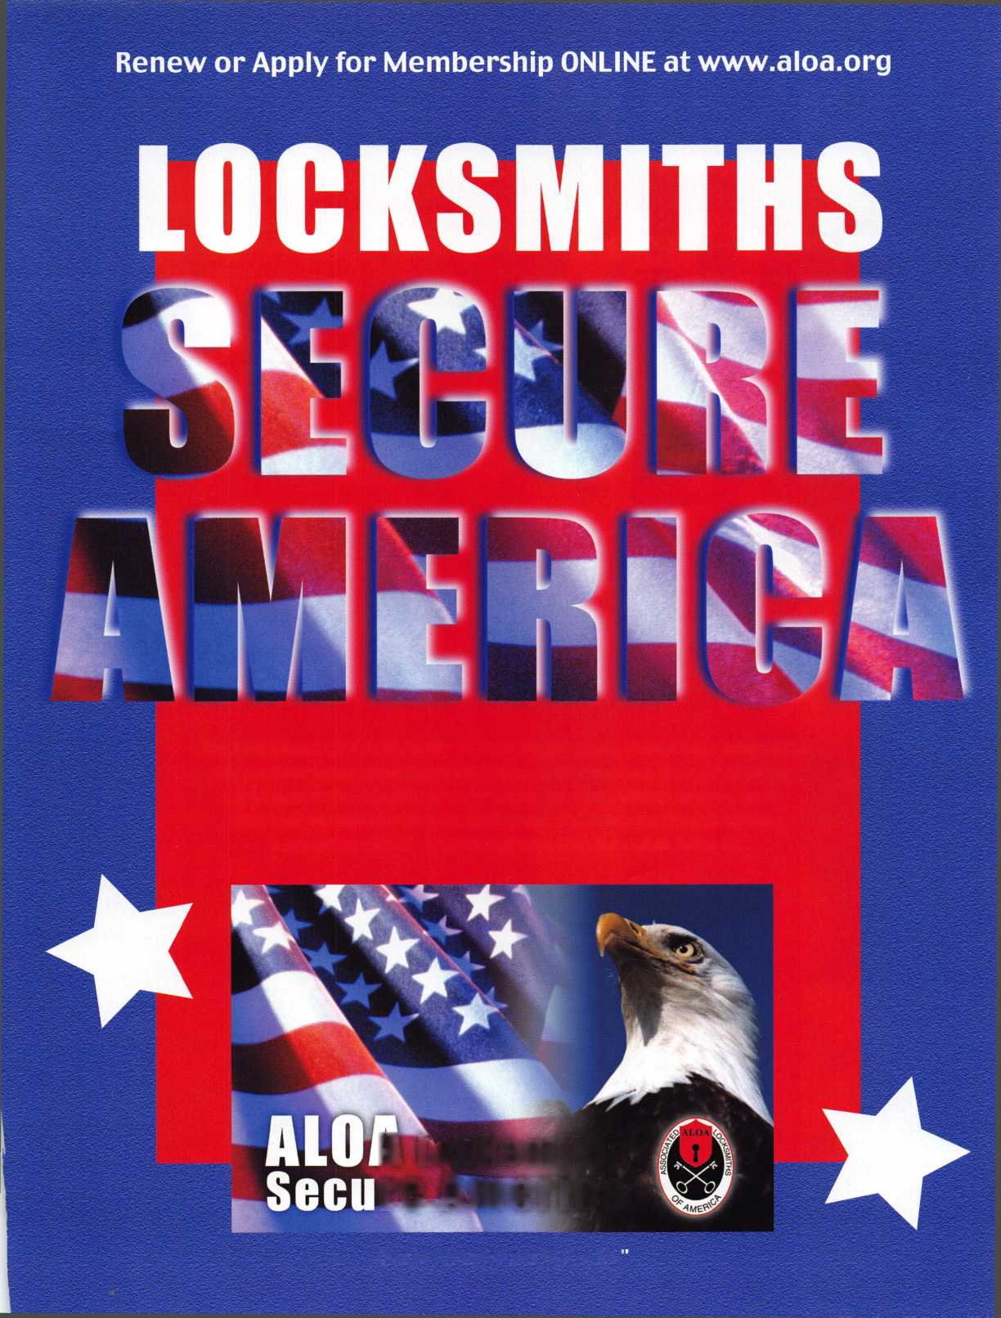

; was

used to house a video

recorder. We needed a

replacement on a

Saturday. The customer

wanted the equip-

back in

service that  
night.

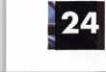

Keynotes • January 2003

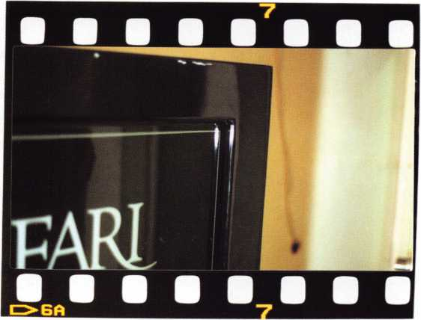

We had four gun safes on the floor,  
but none as heavy as the one  
attacked. The customer wanted a safe  
at least equal to what they had. A call  
to our distributor found they didn’t  
have the same safe in stock, but they  
did have a Safari Safe Company S6140,  
it seemed to fit our needs. But who is  
Safari Safe Company?

According to their brochure, “At Safari Safe  
Company, we’ve drawn on the spirit of the  
safari and combined it with 25 years of build-  
ing the finest series of gun and home security  
safes available.” 25 years? How come I’ve never

heard of them? I checked my library and nothing  
on Safari, so Monday, I called them. I spoke with  
the owner, Chuck Fretwell. He founded the com-  
pany in August of 2002. Currently, they are having  
a well-known safe company produce their safes as  
an OEM. By looking at the pictures, can you ID  
the manufacturer? They offer three different levels  
of gun safes, plus a gun box and a couple of wall  
safes. One of the wall safes is designed for a shotgun.

It is designed to fit between the studs and  
offers an electronic lock with the keypad  
built into the handle for quick access.

Considering all the liability of having a  
gun stored improperly, this wall safe offers  
a nice balance between open storage and  
large gun safe.

Like any good technician, the first thing  
I did after removing the box and putting  
the safe in place was to remove the back  
cover of the door. My first reaction to see-  
ing the inside was Cannon! The concealed  
hinge, boltwork, and bolt detent all

Keynotes • January 2003

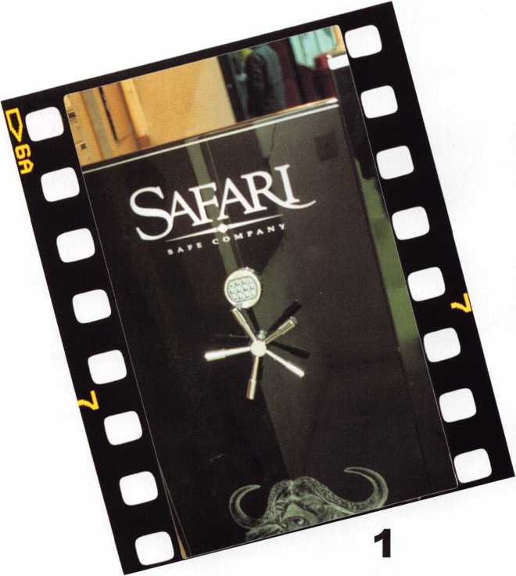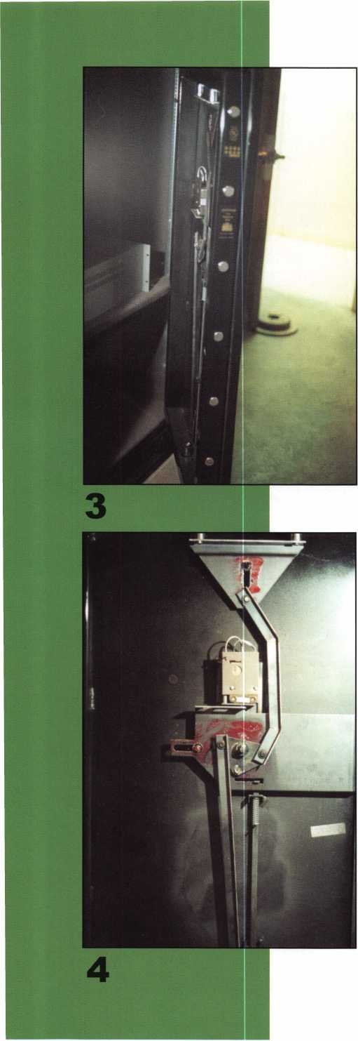

screamed Cannon! During our later phone conversa­tion, I asked Chuck and he confirmed my ID. Cannon is the OEM manufacturer for this new line of gun safes. The boltwork is different between the models, although most gun safes use a vertical down lock mounting, which appears to be the same throughout this line. All of the safes come standard with the LG Basic lock from LaGard. A group 2 mechanical is available for an additional charge.

The Safari series is a unibody 10 gauge steel con­struction. It has a double walled composite steel 1- inch thick door with 3/8-inch hardplate protecting the lock area. The composite is two layers of steel with a piece of 5/8-inch Sheetrock between them. Ten i-inch bolts secure the door to the frame: seven on the side, two on the top and one on the bottom. Attacking this unit is best accomplished using a through-the-spindle-hole spiking technique. I described this technique in an article I wrote on Cannon gun safes (Keynotes, May 2002, page 17); Michael Yarberry originally presented it on the SAVTA web site ([www.savta.org](http://www.savta.org)) website, and also in the NSO newsletter. Failing a spiking attack, drilling for the solenoid is another method of attacking the lock. Or, if it is a mechanical lock, 7/8-inches at 72 for the fence or side drill, and scope the change key­hole. The method you choose will depend on the lock type, whether you have access to the sides and how good you are at repairing the hole.

One of the nicest features of the Safari line is the lifetime warranty against attempted break-in or fire. Not only will they repair or replace the safe they also pay the freight both directions. Safari offers dealer pricing at six or more units and distributor pricing by the truckload. Both dealer and distributor pricing includes freight to anywhere in the 48 states. They can be found at 800/222-1055, or online at [www.safarisafe.com](http://www.safarisafe.com). Q

**26**

Keynotes • January 2003

tt\bers #?(

**For Chapters and  
Affiliates Who  
Recruit!**

If your chapter gets 15  
new members: ALOA will  
send instructors out to  
your site for two free days  
of ACE classes FREE OF  
CHARGE! Plus, the chap-  
ter or affiliate that recruits  
the most new members  
gets three free convention  
packages for our blowout  
show in sparkling Las  
Vegas in July of 2003!

Don't pass up this fantas-

Locksmiths

America

**Membership.  
You're a Pro**

**ALOA**

**Prove**

Attention Current Members! As the best security pros in the world, you play a vital role in making ALOA what it is. You make our industry hym, and we're going to. prove it this year by offering you more benefits than ever. For the entire calendar year of 2002, those who recruit new members will receive special gifts from ALOA. We're asking you to prove you're a pro by sup­porting the only professional organization that exists to help educate, protect and promote security profession­als in America and beyond. Here are some of the details of our campaign:

**For New Members!**

All newly recruited members receive a useful ALOA 11-piece pick set from LAB, plus our stirring "ALOA Locksmiths Secure America" decal for the shop or van.

**For Current Members Who Recruit!**

1 new member: The useful ALOA 11-piece pick set from LAB.

5 new members: A handsome ALOA Polo Shirt (w/ stitched logo)

10 new members: LAB's great Schlage/Kwikset Combination pin kit -- plus membership in the ALOA President's Club, with your choice of a dazzling ALOA ring or a classic ALOA blazer (plus a periodic listing in Keynotes).

tic chance for these gAat free giveaways, ah ™ expanded group of peers with whom to learn and grow, and the same fantastic education, protection and promotion ALOA has been providing for our great profession for almost 50 years! Call us today at 800/532-ALOA (2562) for more informa­tion, or visit us on the web at [www.aloa.org](http://www.aloa.org).

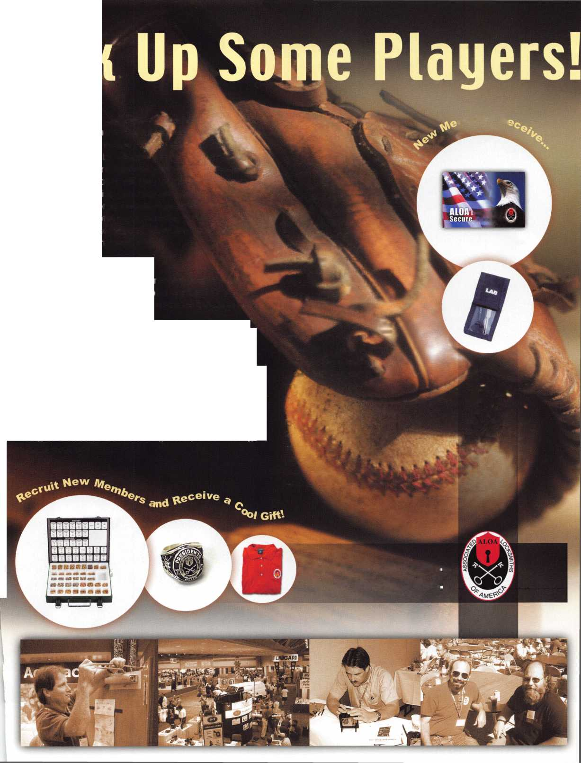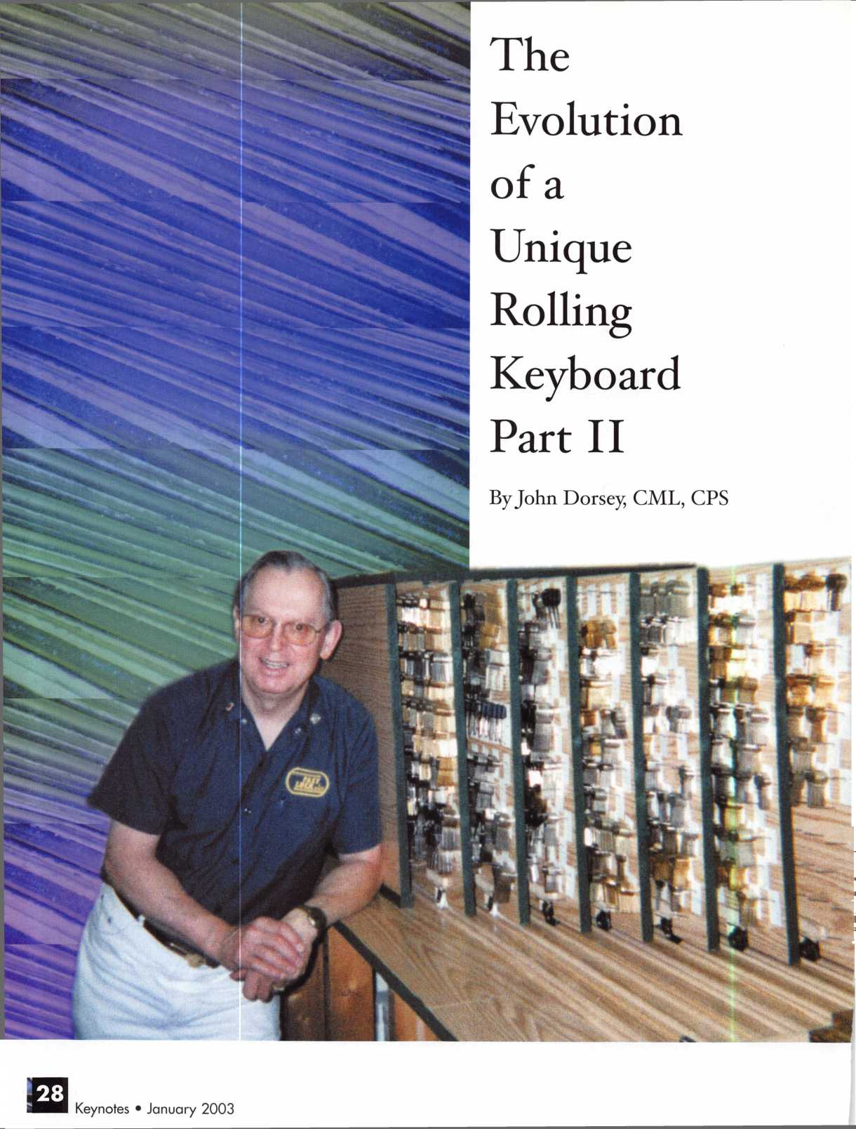

A new and improved rolling keyboard had become a necessity. The original had absolutely worn out. So I didn’t have the option of not building a new one, and the issue was no longer “when,” but how quickly could I get it done? And get it done right, with all the improvements incorporated that have been going through my mind for the past several years... how?

I am a locksmith, a left-brained person; therefore all of the plans and ideas for my new rolling keyboard were in my head, not on paper. First of all, I wanted the new version of rolling keyboards and box to be attractive. So I chose pre-finished (artificial maple) shelving, 3/4-inch particleboard, 23 3/16-inch wide X 97-inch long (that’s right - one inch over eight feet!). Each individual board would be 36 inches long, where the originals were 24X32 inches.

With the boards cut to size, I clamped them together, and with my handheld skill saw, cut 2X2-inch square notches, six inches in both sides of the bottom edges, for the casters. Before I could mount the casters, I had to glue wider pieces of particleboard in the square notches to have a wide enough surface for the casters’ mounting plates (see photo 1). This was all planned to have the caster wheels extend just ha half-inch below the boards. That would give me the maximum surface of each board to lay out the key peg pattern for the most favorable number of pegs per board.

Calculating the most pegs for the space available,

I decided to bypass the pegboard formula of two-inch spacing between of both keys and rows (photo 2).

I made my own template with a 1 7/8-inch for both spacing and rows. (The time invested in making my custom template was well worth the effort!) That for­mat gave me one more peg per row, as well as one additional row per board. Unlike the original rolling keyboard system, I planned the spacing of the top row to make sure adequate room was left for the top track, but also so that the first row of keys would still have room for the key tags.

My template was a piece of scrap particleboard.

I drilled two rows of holes at a 10-degree angle, using my drill press. Clamping the template to the boards,

I used a 1/16-inch drill bit to pre-drill the six-penny peg positions. The bit was measured so it came about 3/32 to 1/8-inches from going through the board.

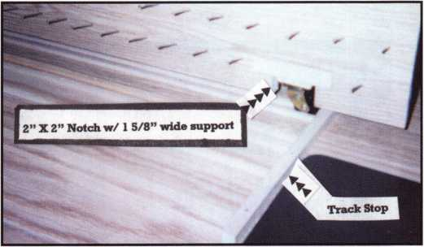

1

Keynotes • January 2003

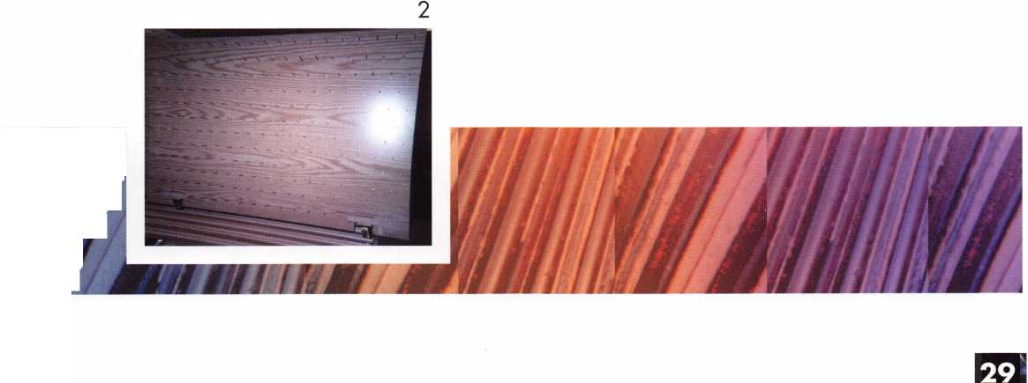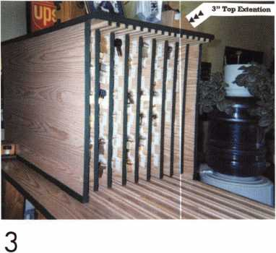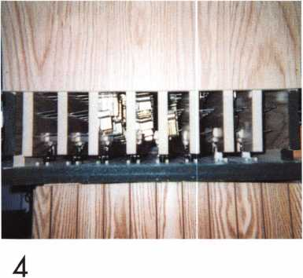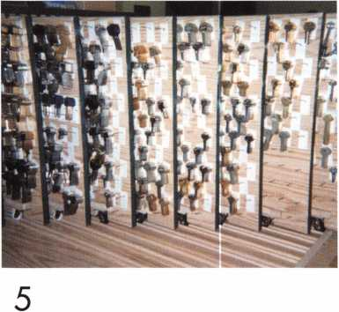

Next, the new boards would require i 1/4-inch diame­ter casters, each with a 50-pound rating. With two casters per board, we would have a 100 pound capac­ity per board. Six-pound penny nails were again used; however, the sides of each nail had their heads ground down to .090 inches - the same size as the rest of the nail, and the sharp point was taken off to help avoid breakthrough on the backside of the boards. You can believe grinding the heads and points of almost 1700 six-penny nails down was not an exciting job, to say the least (see illustration 1).

Next, I devised a nail guide. It was made fro double thick pieces of scrap particleboard, approximately 1 5/8 X 6 inches, drilled at the same 10-degree angle as the template. Needing only one nail hole guide,

I ground the double thick board down so that when a nail was placed in the guide over the pre-drilled hole, and then driven in with a hammer. The guide would stop the hammer, and keep the nail from breaking out the back of the board.

After getting the nails all in place, the next job was to make the box and tracks for the new boards.

I decided on 1/2-inch square oak dowels for the top track, and 1/4-inch oak dowels for the bottom track. (Yeah, I know - I thought dowels were round too!)

I used a piece of scrap particleboard, with two layers of masking tape to install the top dowels so that the

**30**

Kevnotes • January 2003



boards could slide without binding. In a similar fash­ion, I used an actual caster with two layers of mask­ing tape on the sides of the wheel to get the bottom track spacing proper for the wheels to roll without any trouble. The oak dowels were pre-drilled, so the brads would not split when nailed to the top and bottom of the box. Aligning the tracks required some careful execution, but was not all that hard.

The bottom tracks have a dowel going across the end of the track run to stop the boards at the designed end of travel.

The top of the box extends almost three inches beyond the sides. That allows the boards to be pulled out completely and still be held upright. The sides of the box are two inches longer than the actual boards. That allows the boards to be just inside the box instead of flush with the opening (photo 3). The back of the box is of the same pre-finished particleboard as the boards and the rest of the box, but it had to be substantially longer, six feet, 10 3/4 inches, which is one foot, 3/4 inches beyond the bottom track. There is a good reason for that measurement; it is the length of the old rolling board on my counter!

Before I had to say goodbye to my old rolling key­board (see part one in last month’s Keynotes), I had the luxury of not being in a real time crunch. Once I had the new one assembled, I had to make the tran-

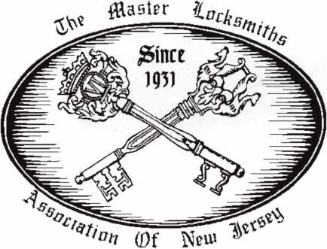

MLANJ 2003  
Annual Convention

(Classes, Trade Show, and Banquet)

April 2nd thru April 6th

Somerset, New Jersey

For More Information:

PO Box 2441

Morristown, NJ 07962-2441  
Fax 973-538-1588

Or visit our web site at

[www.MLANJ.orq](http://www.MLANJ.orq)

Keynotes • January 2003

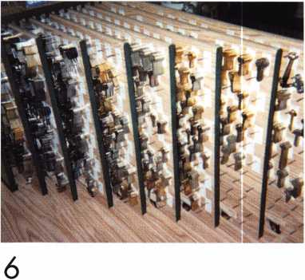

Nail Head ground so nail/peg is 0.090” full length  
Approx 1.9” Total Length

WHmmmKimmmmmmmmmmmr.

0.112” nail head ~ rest 0.090”

2” Total Length

Illustration 1

sition as quickly as possible. Every locksmith can appreciate that when you replace a keyboard with a capacity of 20-odd thousand blanks with a new key­board, getting all those blanks hung up is as thrilling as a root canal.

Hanging the blanks forced me to redesign my format somewhat. For example, some of the blanks (like some Renault, Fiat, Audi, Porsche and Jaguars, along with some old motorcycle blanks) were removed from the boards completely, for lack of anything resembling frequent use. Those, and some others, were placed in boxes that can be located quickly, if and when they are needed.

Necessity again forced me to add another improve­ment to the new boards. Instead of putting the price on the key tags, I now use 1/4-inch round, colored stick-on labels (available at any office supply store). The problem of only having a limited number of col­ors for these labels was easily overcome by modifying the shape of the labels as necessary. After I ran out of the four basic colors of the labels, I cut them in

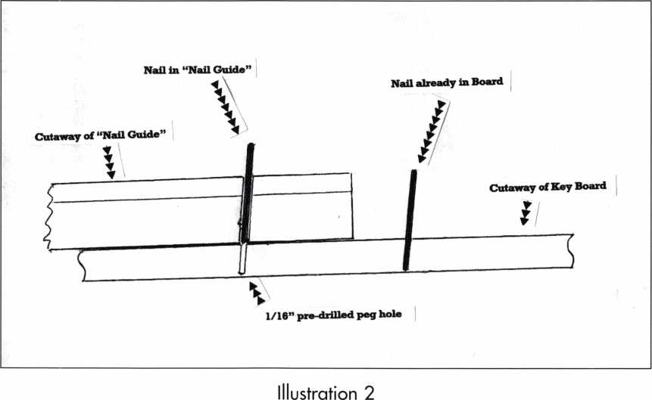

Keynotes • January 2003

half and used half-round “top,” “bottom,” “right” and “left” labels. The yellow labels, I found, worked best when I blackened the background of the key tag with a magic marker. Same for some half-round labels; the black made the very small labels very easy to see, and therefore, identify which price group to charge for keys from any particular peg! (Illustration 3)

My policy for pricing keys is based on several factors: the general price of the blank, the volume (or lack thereof) for sales of that blank, the type of blank (OEM or after market) and the availability of the blank. With the color coding by the small round labels, I can change prices down the road when nec­essary, without having to re-price each key tag.

I started on the new rolling keyboards and box in early July, 2002, and had it operational before I departed for the ALOA convention in Rosemont, IL, later that month. By “operational,” I mean it actually had replaced the old, worn out board. But, all the hanging of keys, etc., was not completed. I am still making a few minor changes, and still getting used to the new layout. But... I love it!! Q

**-KEY PRICES-**

|  |  |  |  |  |  |
| --- | --- | --- | --- | --- | --- |
| □ | $ | 1.75 ( | 1 # | $ | 2.25 |
| • | $ | 2.60 | 1 ^ | $ | 3.60 |
| • | $ | 2.80 ( | 1 ~ | $ | 3.80 |
| □ | $ | 3.25 e | o | $ | 4.60 |
| 4 | $ | 3.00 | I 1 | $ | 6.00 |
| 4 | $ | 5.00 | | 1 1 | 8 | 6.60 |
| 4 | $ | 7.00 | | 5 >' | $ 10.00 | |

Illustration 3

Central Intelligence Agency



Electronic Specialists

The Central Intelligence Agency is seeking Electronics Specialists to work with the best minds in the country while performing a mission critical to our nation.

To qualify for this position, applicants must possess a minimum of an associate’s degree in electronics tech­nology. In lieu of a degree, a certificate of completion for equivalent military, commercial, or industry-recognized electronics school or training programs, or comprehen­sive work experience, as well as a demonstrated profi­ciency in the field of electronics or an electromechanical environment, are required. Knowledge of electronic or manual safe lock servicing, electricity, and alarms, and experience working as a locksmith are ideal.

Applicants will acquire the skills necessary to affect the configuration design, deployment and maintenance of a variety of security systems either via formal classroom training or on the job, working regularly with Area and Regional Security Officers to coordinate overseas securi­ty programs. Regular foreign travel is required throughout the applicant’s career. In addition, you will be expected to serve multiple overseas PCS assignments throughout your career. Applicants will also be expected to engage in administrative duties, as assigned, and work with and lift heavy equipment.

Because of our national security role, applicants must be able to successfully complete medical examinations and security procedures, including a polygraph interview.

The CIA is America’s premier intelligence agency, and we are committed to building and maintaining a work force as diverse as the nation we serve.

To be considered, please apply online by visiting our website at [www.cia.gov](http://www.cia.gov), or send your resume to: Recruitment Center, LI 00 LF7, Dept. AKEY0103, Washington, DC 20505.

[www.cia.gov](http://www.cia.gov)

An equal opportunity employer and a drug-free work force.

Keynotes • January 2003

Success Breeds Confidence

But Confidence Also Breeds Success.

John C. Elliott Jr, CML CPS

Who Knows Which Comes First?

It takes confidence to make a buying decision. But,  
how can your customer have confidence in you, your  
product and your company unless you have confi-  
dence in yourself?

Confidence is hard to “ fake Lack of confidence  
shows in a persons’ face, speech, gestures, and their

exaggerated claims.

Where does CONFIDENCE come  
from?

Confidence comes from many areas;

I will touch on several here in this  
article.

Preparation. A person, who is pre-  
pared to take advantage of every sales  
opportunity and is knowledgeable

about their product or service, cannot help  
facing each sales interview with greater confidence  
than a person who lacks the necessary preparation.

Practice. A person who spends hours practicing and  
polishing a presentation on their given product or  
specialty, is bound to radiate more confidence when  
they face the prospective sale. The one who is not

quite sure of what they are going to say reflects uncer-  
tainty, and lack of conviction.

Time. It takes time to learn the fundamentals. Take the time to learn it right. Don’t expect overnight suc­cess. We have enough self-proclaimed experts, who have read one book and then hit the streets thinking they know it all.

Knowledge. When you know your product or service from top to bottom, and exactly how it compares to the competition. When you know so much about a customers’ problem that you become sure you can

help them, how can you help not be confident.

Education. While this might fit into the previous sec-  
tion, “Knowledge”, it is however much different. You  
will never stop learning new ways, new things, or even  
and old way of doing something. Many times you find  
yourself with other locksmiths at the local lock supply  
house, chatting or swapping stories. If you have a

local locksmith association, I would suggest that  
you join it, as at the meetings you will learn

from those that have been in the industry  
for a number of years as well as the new-  
bies, they all have something to offer.  
They have very good classes and of  
course great bull sessions where the  
new toys will be shown. I get so much  
knowledge this way. Most associations  
are based on education an training and will

welcome you in even if you are not yet a lock-  
smith, but are sponsored by one and regularly  
involved in some type of training. I have heard of  
people going into a locksmith shop and after several  
meetings actually working for a very minimum wage  
or even for free just to learn. They would do every-  
thing from sweeping the floor, be a gopher for tools  
etc., to helping drill open the safe at the local grocery  
store. There are trade shows, usually hosted by a lock  
supplier. They show off all of the latest equipment  
and tools, but best of all, they will have some great  
classes given by manufactures on their products as  
well as other classes offered by the locksmith associa-  
tion^).

If there is something you are better at, then learn all  
you can about it. Learn about the related areas and so  
on, as no matter how much you learn about some-  
thing, there is always something else to learn about it.



Keynotes • January 2003

Are you a shade less confidant than you would like to be? Is it caused by failure in any one of the aforemen­tioned areas? If you believe a remedy is needed and you have made up your mind to do something, then get with it. It costs you money not to be prepared.

Confidence on your part breeds confidence on the part of your customer. A confident attitude breaks down the barriers of uncertainty, and disbelief. With these barriers out of the way, you can have a straight road for telling a convincing story about your product and services.

The Associated Locksmiths of America, is an organi­zation prepared to help its members with any prob­lems they may encounter. Whether it is in a technical manner, or in the area of sales, they are ready to help. The Association has resources available to educate the locksmith and enable that person to be prepared.

Classes in many areas are offered through local associ­ation meetings, and at the national convention which is held in different cities every year. They have a test­ing program, called the Proficiency Registration Program or PRP for short. When taken, it tests the knowledge that a person in the locksmith field should know and shows this person the areas in which they need to polish on or learn. Remember this, your cus­tomers) are the real test.

I urge you to become involved in your future. Learn all you can, as then you will be prepared, and at your best for anything. You see your training and education will never stop. I have been doing this for 33 years and am continuously learning new things.

Practice your specialty learn all you can and become confident in yourself. Q

Complete Safe Opening Kit

Ultimate Safe Deposit Opening Kit

IT S ALL HERE.

* Neutralization Kit
* Safe Deposit ID manual
* LeFebure 7700 Opening Tool
* Diebold 17570 Opening Tool
* 7700/17570/4500 Change Tool
* Mosler 3175 Reset Tool
* Safe Deposit Opening Video

LKM1010KIT $680.59

IT'S ALL HERE.

* 17" Hawkeye Limited Borescope
* Magnum Bullet Drill Rig
* Lock-Amp Amplifier
* Dial Puller
* Emergency Dial
* Straight Light Kit
* 6 Piece Punch Set
* 5 - Mr. Twister 1 /4"x4"

800.654.0637 I [www.lockmasters.com](http://www.lockmasters.com)

LKM3113KIT $1,455.62

See all our new products.

CALL FOR YOUR FREE COPY TODAY.

IOCKMASTERS

Keynotes • January 2003

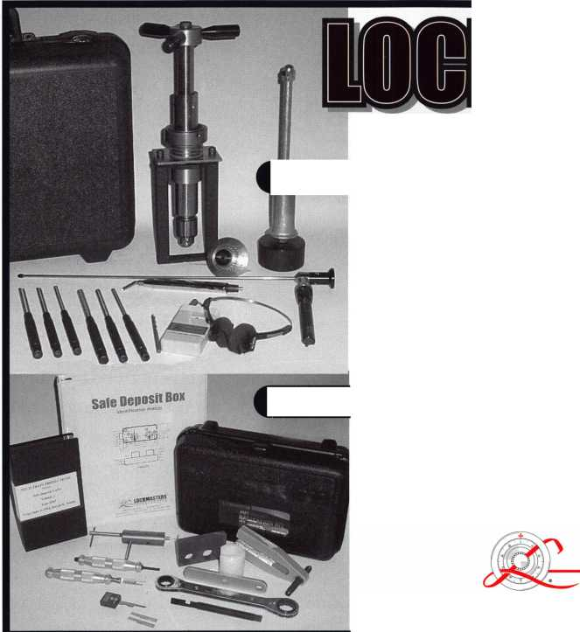

**A New Ifear**

2003. It is easy for us to  
worry about the economy, the  
state of world affairs, or to dwell  
on our business last year.

But how often do we stop  
to think about how lucky we  
really are to be American?  
We have the privilege to  
participate in a free economy  
that gives entrepreneurs a  
chance to pursue a dream.  
How privileged we are to  
be part of the thriving  
security industry. We are  
fortunate to be members  
of ALOA, an international  
association with resources for further-  
ing our education, and a way to meet  
others in our profession.

The New Year is a time to celebrate, and to be thankful for our customers, friends, and business associates, that we are lucky enough to encounter every day. It is a time to appre-



A New Tear...

And A Reason to be Thankful!

By Claire L. Cohen, CML

ciate the advances in technology that have trans-  
formed our industry in just a few years. Despite the  
headlines every night (which could sadden the most  
optimistic), we have a great deal to be thankful for as  
we roll into the New Year.

The New Year may be a time to think about  
how we can do something to enhance

someone else’s life. It may be an indi-  
vidual effort, a community project or  
a company effort. We may decide  
to donate money for a holiday meal  
for the needy. Perhaps a donation of  
time to use our skills to enhance the  
lives of others may be appropriate.

We can make the effort and boost

morale with the satisfaction of doing some-  
thing simple, but so important.

Think of some way to overly thank your customers. It doesn’t have to be fancy-even a “thank you for your business” card would do. But do something! The dol­lar can be spent in many places other than yours, so don’t take anyone’s business for granted.

Look around you and thank those who make it possi­ble for you to be in business-your family, friends, busi­ness associates and employees. Make a conscious effort to acknowledge your “backbone” with some­thing above and beyond a paycheck or verbal thank you. The family that understands about late night or weekend work is invaluable. But don’t abuse their flexibility and patience.

After all, what is the purpose of all your hard work if it’s not to enjoy the success with those who mean the most to you?

Take a moment to be thankful for your own position in the world. If you are happy and take pride in what you do, you are fortunate. If not, what is your vision for yourself and how on track are you to be where you want to be? Develop a personal vision.

I am thankful for the opportunity to express my thoughts to you, and to be associated with our indus­try. Have a wonderful New Year...2003. Q



Keynotes • January 2003

**3**



e g i s I a t i v e p d a t e

2003 WILL BE A BUSY LEGISLATIVE YEAR FOR ALL LOCKSMITHS

"If you don't know where you're going, you could wind up someplace else" - Yogi Berra

This year we ALL need to watch where we're going in state capitols across the U.S., or we could very well end up someplace else. Careful monitoring and grassroots involvement will be key. That's where ALOA offers you all the resources you need right online at [www.aloa.org/news/legcom.cfm](http://www.aloa.org/news/legcom.cfm)!

YOUR S FOR THE ASKING

Many of you already know that ALOA tracks leg­islation, and notifies members of pending bills that could effect their business. But many of you may not know that the resources that we use to keep you abreast of what's going on, is also AVAILABLE TO YOU TOO. The following are the legislative resources provided by ALOA:

CONTACT YOUR LEGISLATOR - we have an effective tool for bringing locksmiths and their state legislators closer together - right through the ALOA web site. Our service connects locksmiths to every member of the 50 state legis­latures and the US Congress, and provides up-to-date information about key issues. It creates personalized cor­respondence that can be sent via e-mail or printed out as a letter for faxing or mailing purposes. Grassroots lobby­ing at its finest!

STATENET - This is ALOA's legislative monitoring service.

We can sign on to this everyday via the computer, and type in a few keywords like "alarm," "locksmith," "electri­cian," "electronic security," and immediately bring up any bills or regulations that were introduced that effect our industry. Heard a rumor that a bill was introduced? Call us and find out for sure!

STATE YELLOW BOOK- This quarterly-updated resource has phone and fax numbers for every state representative, state senator, committee chair, listing of committee mem­bers, and everyone in the executive or judicial branch of state government. If you need a number, just call!

STATE LEGISLATIVE SOURCEBOOK- This handy little guide has every state agency listing, media service, news serv­ice, state lobbyist etc. Again, if you need a number, just call!

INTERNET SITES OF STATE LEGISLATORS- We've "book- marked" on our website every state site, including every legislature's homepage. This allows us to look up text of bills, committee agendas, and even contact legislators via e-mail. A link to all bills is just a click away!

MODEL LAWS- Need a copy of any state law? We've got 'em! We've also written up summaries of many of the laws that effect locksmiths or the access control industry. Even ALOA has a model law you can use.

INDUSTRY MEMBERSHIPS- To help keep the "pulse" of the security industry, ALOA is involved in many other organi­zations and coalitions including the National Conference of State Legislators, The Electronic Systems Alliance, SIA and NBFAA Government Relations Committees, and the Consortium for Electronic Systems Technicians. If you are interested in being copied on any minutes, just let us know!

BLAST FAX SYSTEM- Through ALOA's "blast fax" and "fax on demand" capabilities, we can immediately fax updates in a timely manner, and notify members of legis­lation effecting them in their state within minutes of a bill's introduction.

However, as we continue to expand our resources and become more competitive in the legislative arena, we need the monetary resources to match our successes. In your new dues billing, you will notice a donation of at least $14.95 to the Legislative Fund. Please add your donation onto your annual dues. This is only the minimum that

Keynotes • January 2003

we are asking, and encourage you to give more if you can. Those that contribute will be given a Legislative Action Network Member kit to use in their grass roots efforts. This kit includes:

* Legislative Action Network Update newsletter alerting you to important legislation in your state and around the country.
* Listing of your state representatives and senators for use in communicating with your elected officials (hard copy and disk).
* Guide to lobbying in your state capital.
* LAN stationary and envelopes.
* LAN lapel pin designating you as a special ALOA LAN member.
* Recognition in Keynotes magazine.
* An invitation to the exclusive LAN reception at the annual ALOA convention.

Members who donate $100 or more become Legislative Action Network Council members, and enjoy the following extra benefits: A reserved place of distinction on the special LAN Council; Discounts on ALOA bookstore items;

10 % rebate on all ACE classes; Complimentary Legislative Convention merchandise.

**Buying From Nebs**

professional **Business**

Holds the Key to

Savings’.

Put a lock on spending

call, order **&** SAVE-'

Professional Business Products, your  
Associate ALOA Member, offers you  
lower prices, two color ALOA logo  
on standard forms and rebates to ALOA!

**For more information, visit us online: [www.professionalbusinessproducts.com](http://www.professionalbusinessproducts.com) or call 1-800-355-6322 for our catalog.**

*Professional*

*Business*

*Products*

a

Keynotes • January 2003

**3**



EMPLOYMENT

EXPERIENCED LOCKSMITH

Established and expanding company in central NJ is seeking experienced help in residential/commercial/auto/access control/safe work. Top pay for top mechanics, along with medical, dental, paid vacation, two days off per week, and no night calls.

Apple Locksmith • 4030 Route 9 South Morganville, NJ 07751 • 732/970-1500 or fax resume to 732/970-9725 (attn: Andy or Jack)

AUTOMOTIVE LOCKSMITH WANTED

Relocate to South Florida and throw away your deadbolts and three keys for a dollar.

We run over 300 calls per week. You must own a truck with tools and code equipment to cut all foreign and domestic keys. You can earn $800 to $1500 per week. South Florida Lock and Safe. 800/9280-2926. Please if no truck or tools, no calls.

LOCKSMITH WANTED

Rapidly growing Lock and Safe business in N. W. PA seeks experienced locksmiths in any or all phases of the industry. Our work is 90% Commercial, Institutional and Financial Institutions. We are a resort community offer­ing Boating, Hunting, Fishing and numerous Golf Courses. If you would like to experience Rural living, come join us.

Contact:Tom Uhlig, CPS Uhlig Lock & Safe • (814) 724-2255 (814) 724-1687 fax e-mail: [lockdoctor@alltel.net](mailto:lockdoctor@alltel.net)

BUSINESS FOR SALE

BUSINESS FOR SALE

32 years. Need to retire. Will sell business with or without 1 800 square foot building on major downtown street. Only locksmith in county. Growing west Texas area. Call 915/336-3278 and ask for Dean.

WANTED TO BUY/SELL

NEED AUTO INFO?

Do you do exotic autos? If you are called to provide keys for a Panoz Espirante, Here is contact info for the company - they provided key codes, transponder codes and are very helpful: Panoz Auto Development Company

1. 101 Highway 124 Hoschton, Georgia 30548 Tel: (770) 867-4796

Toll Free: 1-888-GOPANOZ (467-2660)

Fax: (770) 307-1714

E-mail: [panozauto@panozauto.com](mailto:panozauto@panozauto.com)

FOR SALE

5 Schlage A53PD ORB 626 Entry locksets @ $20 each

1. US1 760BF DL door closers @ $50 each
2. US 1735 AL door closers @ $50 each 1 US 1703 DL door closer @ $25

1 US 1743 DL door closer @ $30 1 US 1744 DL door closer @ $30 1 Monarch #19 Rim Exit Panel Device 36" AL @ $75

1 US2870 AL Rim Panic Device @ $100 Contact: Builders Hardware Sales and Service Phone: 610/495-5465 e-mail: [barlocks@juno.com](mailto:barlocks@juno.com)

OVERSTOCK, NEW VON DUPRIN

1. . E99K US26 3' $ 525 ea.
2. 22TP F 3' 689 $250 ea.
3. 3347TL3' US26D $720 ea.

I have more 9947,3347,2227,9975 for sale. Please cafl Kevin at 915-553-3145 or e mail: [reddog2501@excite.com](mailto:reddog2501@excite.com) .

NEED CASH?

Have you recently sold your locksmith busi­ness, or are you selling it now? We can give you a lump sum of cash now for all or a por­tion of your remaining payments. RED OAK FUNDING. 630/483-0335.

BARGAIN OF THE CENTURY FOR SALE

* 4-drawer fireproof file cabinets, all 350 degree, one hour, perfect condition
* 5 Fireking with Medeco locks
* 3 Schwab
* 1 Hercules by Meilink
* 1 Diebold
* 1 Meilink

For further details, call Allied Locksmiths (954/704-8215), or e-mail to [alliedlock@aol.com](mailto:alliedlock@aol.com).

FOR SALE

Fort Lock Tubular Model KM#7, llco Model 21 83HM, llco Model 2585, Jenson Micro Dial Model 1275. Plus, HUGE octagon rotating cabinet loaded with merchandise. ALL PRICED TO SELL! 847-251-2541. Central Time­evening calls are best. Ask for Jake

WHOLESALE SAFE DEPOSIT LOCKS

Allied, Diebold, Herrin Hall & Mavin, llco, Lefabure, Mosler, Precission, S&G, Security Corp., Yale. Locks from early 1900s to current. Call or e-mail for lock type and pricing sheet. Quantity discouts. Call WBI (888)329-7265 or (954)484-2404 or [sales@wbi.us](mailto:sales@wbi.us).

Classified Advertising Policy

Classified advertising space is provided free of charge to  
ALOA members, and fora fee of $.60 per word, $ 15 mini-  
mum for non-members. Classified ads may be used to  
advertise used merchandise and overstocked items for sale,  
"wanted to buy" items, business opportunities, employment  
opportunities/positions wanted and the like. Members or  
non-members wishing to advertise services or new mer-  
chandise for sale may purchase a "Commercial Classified  
Ad," fora fee of $1.30 per word, with a minimum of $40.  
Each ad will run for two issues. For blind boxes there is a  
$5 charge to members and non-members. All ads must be  
submitted in writing to the ALOA office by the fifteenth of  
the month, two months prior to issue date. Send to  
Keynotes Classifieds, 3003 Live Oak St., Dallas TX 75204-  
6186. ALOA reserves the right to refuse any classified  
advertisement that it deems inappropriate according to the  
stated purpose of the classified advertising section.

Keynotes • January 2003

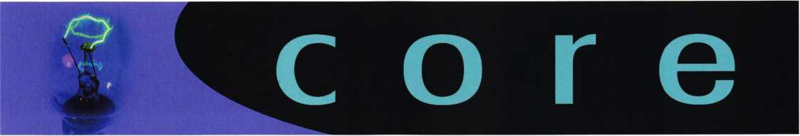

Corrections

In last month's issue of Keynotes (December, 2002), there was a mistake that may lead ALOA members into a servicing error. In our article on the Cencon ATM electronic lock (page 23), photo 14 appears as the same image as photo 10. We apologize for any trouble this may have caused. Here is the correct photo, along with its corresponding caption:

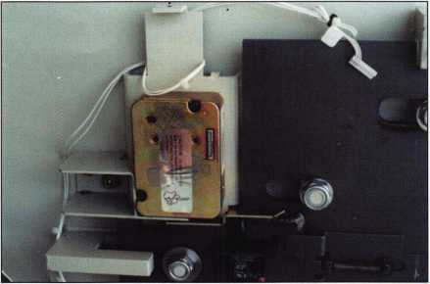

Caption: Back cover is installed. The lock reset key is under the tape.

ALOA's POSITIVE ID POLICY:

* ALOA locksmiths are instructed to use the following posi­tive identification policy when servicing lockouts:
* Notify Caller. When a call comes in to request lockout services, ask the caller if he/she has identification and authority to open the lock.
* Complete Form. Upon arrival at the job site, the lock­smith should complete an Authorization Form that asks for the name, address, phone number, identification number and property description from the customer.
* Verify I.D. Verify the customer's photo-identification card and compare it to the information provided by the cus­tomer. If no photo-ID card is available, ask for some other reasonable form of ID.
* Verify Authority. The locksmith should inquire as to what authority the customer has to open the lock, and request to see any reasonable and appropriate evidence that could verify the authority. This may be impossible in some cases.
* Ask for Signature. Ask the customer to sign the Authorization Form, which should contain a statement that (a) the information given by the customer is correct,

1. the customer has the authority to open the lock, and
2. the customer shall identify and hold harmless the lock­smith against liability.

* Optional Last Resort. If you have any suspicions that the customer is giving false information or does not have authority to open the lock, say that you will be happy to open the lock provided a law enforcement officer is present. If the customer agrees, call the police; if not, leave.

File the Form. Keep the Authorization Form on file for a rea­sonable period of time.

Let Us Know!

If you have an opinion to offer on ALOA, the state of the industry, or life in general, we want to know about it! Submissions to the "Mailbox" section of Keynotes are printed on a space-available basis. Write to: "Letters to the Editor"; ALOA; 3003 Live Oak Street; Dallas, TX, 75240; FAX 214/827-1810; e-mail: [editor@aloa.org](mailto:editor@aloa.org).

Need Help?

At ALOA, we want to make sure you are getting as much bang for your membership dues buck as we are able to give you. If you have had problems getting membership services, or have a question regarding member services, please con­tact Bill Gibson, executive director, at 800/532-2562, or e- mail: [charlie@aloa.org](mailto:charlie@aloa.org).

New certifications

CRLs

Jim Coulter Robert Cullum Paul Frederick James Fredrick Steve Hamann Karen Milligan Michael Moriarty John Rosselli Alfonso Sgritta

Gilmer, TX  
Hingham, MA  
Altoona, PA  
Altoona, PA  
West Jordan, UT  
Grove City, OH  
North Reading, MA  
Hamden, CT  
Stamford, CT

Keynotes • January 2003

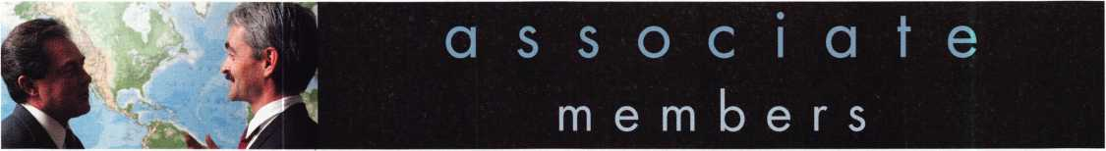

Distributor

ADI Inc.

Phone: 631-692-1000 Fax: 631-692-301 1

Accredited Lock Supply Co.

Phone: 201-865-5015 Fax: 201-865-0030 [www.acclock.com](http://www.acclock.com)

Ace Lock & Security Supply

Phone: 908-688-7666 Fax: 908-688-2442 [www.acelock.com](http://www.acelock.com)

Action Hardware Inc.

Phone: 800-662-6695 Fax: 800-930-2329

Andrews Wholesale Lock Supply

Phone: 717-272-7422 Fax: 717-274-8659 [www.andrewslock.com](http://www.andrewslock.com)

Boyle & Chase Inc.

Phone: 800-325-2530 Fax: 800-205-3500 [www.boyleandchase.com](http://www.boyleandchase.com)

Clark Security Products

Phone: 800-854-2088 Fax: 619-974-5284 [www.clarksecurity.com](http://www.clarksecurity.com)

Cook's Building Specialties

Phone: 505-883-5701 Fax: 505-883-5704

Dire's Lock & Key Company

Phone: 303-294-0176 Fax: 303-294-0198

Direct Security Supply, Inc.

Phone: 800-252-5757 Fax: 800-452-8600

Doyle Security Products

Phone: 800-333-6953 Fax: 612-521-0166 [www.doylesecurity.com](http://www.doylesecurity.com)

Dugmore and Duncan, Inc.

Phone: 888-384-6673 Fax: 888-329-3846

E. L. Reinhardt Co., Inc.

Phone: 800-328-1311 Fax: 651-481-0166 [www.elreinhardt.com](http://www.elreinhardt.com)

Ewert Wholesale Hardware

Phone: 800-451-0200 Fax: 708-597-0881

Fairway Supply, Inc.

Phone: 214-350-0021 Fax: 214-352-4299 [www.fairwaysupply.com](http://www.fairwaysupply.com)

Foley-Belsaw Company

Phone: 800-821-3452 Fax: 816-483-5010 [www.foley-belsaw.com](http://www.foley-belsaw.com)

Fried Brothers Inc.

Phone: 800-523-2924 Fax: 215-592-1255 [www.fbisecurity.com](http://www.fbisecurity.com)

H L Flake Co.

Phone: 800-231-4105 Fax: 713-926-3399 [www.hlflake.com](http://www.hlflake.com)

H.S. & S. Wholesale Distrib.

Phone: 313-342-6777 Fax: 313-342-7580

Hans Johnsen Company

Phone: 214-879-1550 Fax: 214-879-1530 [www.hjc.com](http://www.hjc.com)

Hardware Agencies, Ltd.

Phone: 416-462-1921 [www.hardwareagencies.com](http://www.hardwareagencies.com)

Howard Keys

Phone: 704-509-4944 Fax: 704-509-6248 [www.howardkeys.com](http://www.howardkeys.com)

IDN Incorporated

Phone: 817-421-5470 Fax: 817-421-5468 [www.idn-inc.com](http://www.idn-inc.com)

Intermountain Lock & Supply

Phone: 800-453-5386 Fax: 801-485-7205 [www.intermountainlock.com](http://www.intermountainlock.com)

Jo Van Distributors

Phone: 416-752-2238 Fax: 416-752-7282 [www.jovanlock.com](http://www.jovanlock.com)

Lockmasters, Inc.

Phone: 859-885-6041 Fax: 859-885-7093 [www.lockmasters.com](http://www.lockmasters.com)

Locks Company

Phone: 800-288-0801 Fax: 305-949-3619

Locksmith Ledger International

Phone: 770-886-0800 Fax: 770-889-7703 [www.lledger.com](http://www.lledger.com)

M. Zion Company

Phone: 212-349-8677 Fax: 212-964-0495 [www.mzion.com](http://www.mzion.com)

McDonald Dash Locksmith Suppl7

Phone: 800-238-7541 Fax: 901-366-0005 [www.mcdonalddash.com](http://www.mcdonalddash.com)

McManus Locksmith Supply, Inc.

Phone: 704-333-9112 Fax: 704-332-8664

Monaco Lock Co.

Phone: 800-526-6094 Fax: 800-845-5625 [www.monacolock.com](http://www.monacolock.com)

Omaha Wholesale Hardware

Phone: 800-238-4566 Fax: 402-444-1664 [www.omahawh.com](http://www.omahawh.com)

Phoenix Safe International LLC

Phone: 765-483-0954 Fax: 765-483-0962 [www.phoenixsafeusa.com](http://www.phoenixsafeusa.com)

Professional Business Products

Phone: 248-360-3979

Fax: 248-360-3982

[www.professionalbusinessproducts](http://www.professionalbusinessproducts).

RA-Lock Company

Phone: 972-775-6301 Fax: 972-775-6316 [www.ralock.com](http://www.ralock.com)

SecureRite.Com

Phone: 800-241-3930 Fax: 858-974-5269 [www.SecureRite.Corn](http://www.SecureRite.Corn)

Security House

Phone: 905-669-5300 Fax: 905-660-6313 [www.securityhouselock.com](http://www.securityhouselock.com)

Sentry Security Fasteners

Phone: 309-693-2800 Fax: 800-693-2872

Somerset Security Products

Phone: 800-881-5206 Fax: 800-206-9949

Southern Lock and Supply Co.

Phone: 727-541-5536 Fax: 727-544-8278 [www.southernlock.com](http://www.southernlock.com)

Stone & Berg Wholesale

Phone: 800-225-7405 Fax: 800-535-5625

The Locksmith Store Inc.

Phone: 847-364-5111 Fax: 847-364-5125 [www.locksmithstore.com](http://www.locksmithstore.com)

Timemaster Inc.

Phone: 859-259-1878 Fax: 859-255-0298 [www.time-master.com](http://www.time-master.com)

Top Notch Distributors, Inc.

Phone: 800-233-4210 Fax: 800-854-4146 www.4topnotch .com

U.S. Lock Corp.

Phone: 800-925-5000 Fax: 800-338-5625 [www.uslock.com](http://www.uslock.com)

Manufacturer

A & B Safe Corporation

Phone: 800-253-1267 Fax: 856-863-1208 [www.a-bsafecorp.com](http://www.a-bsafecorp.com)

ABUS Lock Company

Phone: 800-352-2287 Fax: 602-516-9934 [www.abus.com](http://www.abus.com)

Abloy Door Security

Phone: 800-465-5761 Fax: 514-335-0430 [www.abloy.com](http://www.abloy.com)

Adams Rite Mfg Company

Phone: 800-872-3267 Fax: 800-232-7329 [www.adamsrite.com](http://www.adamsrite.com)

Adesco Safe Mfg. Company

Phone: 800-821-6803 Fax: 562-408-6427 [www.adesco.com](http://www.adesco.com)

Adrian Steel Company

Phone: 800-677-2726 Fax: 517-265-5834 [www.adriansteel.com](http://www.adriansteel.com)

Alarm Lock Systems Inc.

Phone: 800-252-5625 Fax: 516-789-3383 [www.alarmlock.com](http://www.alarmlock.com)

All Five Tool Company, Inc.

Phone: 860-583-1691 Fax: 860-583-4516 [www.all5tool.com](http://www.all5tool.com)

American Lock Company

Phone: 708-534-2000 Fax: 708-534-0531 [www.armericanlock.com](http://www.armericanlock.com)

American Security Products

Phone: 909-685-9680X1083 Fax: 909-685-9685 [www.amsecusa.com](http://www.amsecusa.com)

BWD Automotive

Phone: 334-872-6524 Fax: 334-874-6011 [www.bwdautomotive.com](http://www.bwdautomotive.com)

Baldwin Hardware

Phone: 610-796-4012 Fax: 610-796-4493

[www.baldwinhardware.com](http://www.baldwinhardware.com)

Be-Tech Security Systems Ltd.

Phone: 852-231-67447 [www.be-tech.com.hk](http://www.be-tech.com.hk)

Buddy Products

Phone: 800-886-8688 Fax: 312-733-8356 [www.buddyproducts.com](http://www.buddyproducts.com)

COMPX Security Products

Phone: 864-297-6655 Fax: 864-297-9987 [www.nclnet.com](http://www.nclnet.com)

**42**

Keynotes • January 2003

associate

members

Curtis Industries,

A Barnes Distr.

Phone: 800-555-5397 Fax: 800-867-6020 [www.curtisindustries.com](http://www.curtisindustries.com)

D&D Technologies (USA), Inc.

Phone: 714-677-1300X292 Fax: 714-677-1299 [www.ddtechusa.com](http://www.ddtechusa.com)

DETEX Corporation

Phone: 800-729-3839 Fax: 830-620-6711 [www.detex.com](http://www.detex.com)

DORMA

Architectural Hardware

Phone: 717-336-3881 Fax: 717-336-3500 [www.dorma-usa](http://www.dorma-usa) .com

Don-Jo Manufacturing, Inc.

Phone: 978-422-3213 Fax: 978-422-3467 [www.don-jo.com](http://www.don-jo.com)

Door Controls International

Phone: 800-742-3634 Fax: 800-742-0410 [www.doorcontrols.com](http://www.doorcontrols.com)

ESP Lock Products Inc.

Phone: 978-562-3481 Fax: 978-562-9859

FireKing Security Products

Phone: 800-457-2424 Fax: 800-896-6606 [www.fireking.com](http://www.fireking.com)

HES, Inc.

Phone: 623-582-4626 Fax: 623-582-4641 [www.hesinnovations.com](http://www.hesinnovations.com)

HPC, Inc.

Phone: 847-671-6280 Fax: 847-671-6343 [www.hpcworld.com](http://www.hpcworld.com)

Hongtai Lock Co. Ltd.

Phone: 137-238-1414 Fax: 208-793-3856

INTELLIKEY Corp.

Phone: 800-226-0703 Fax: 321-724-0811 www. i n te 11 i key. co m

llco Unican

Phone: 252-446-3321 Fax: 252-446-4702 [www.kaba-ilco.com](http://www.kaba-ilco.com)

Jet Hardware Mfg., Co.

Phone: 718-257-9600 Fax: 718-257-0973 [www.jetkeys.com](http://www.jetkeys.com)

KABA High Security Locks

Phone: 860-621-3601 Fax: 860-621-9727 [www.kabausa.com](http://www.kabausa.com)

KEY-BAK/West Coast Chain Mfg.

Phone: 909-923-7800 Fax: 909-923-0024 [www.keybak.com](http://www.keybak.com)

Keri Systems Inc.

Phone: 408-451-2520 Fax: 408-441-0309 [www.kerisys.com](http://www.kerisys.com)

Knaack Manufacturing Co.

Phone: 800-456-7865 Fax: 815-459-9097 [www.weatherguard.com](http://www.weatherguard.com)

LAB Security

Phone: 800-243-8242 Fax: 860-583-7838 [www.labpins.com](http://www.labpins.com)

LCN Closers Div. of Ingersoll

Phone: 815-875-3311 Fax: 815-879-1497 [www.lcnclosers.com](http://www.lcnclosers.com)

La Gard Inc.

Phone: 310-325-5670 Fax: 310-325-5615 [www.lagard.com](http://www.lagard.com)

Lucky Line Products, Inc.

Phone: 858-549-6699 Fax: 858-549-3241 [www.luckyline.com](http://www.luckyline.com)

M.A.G. Security

Phone: 714-891-5100 Fax: 714-892-6845 [www.magsecurity.com](http://www.magsecurity.com)

MARKS, U.S.A.

Phone: 516-225-5400 Fax: 516-225-6136 [www.marksusa.com](http://www.marksusa.com)

MARRAY Enterprises

Phone: 408-970-0213 Fax: 408-970-8767 [www.marray.com](http://www.marray.com)

MCS Communication Systems

Phone: 514-444-2040 Fax: 514-444-2029 [www.mcscommunication.com](http://www.mcscommunication.com)

MMD, Inc.

Phone: 865-428-3611 Fax: 865-453-4136

MUL-T-LOCK USA, Inc.

Phone: 800-562-3511 Fax: 973-778-4007 [www.mul-t-lock.com](http://www.mul-t-lock.com)

Master Lock Company

Phone: 414-444-2800 Fax: 414-444-0322 [www.masterlock.com](http://www.masterlock.com)

Medeco Security Locks

Phone: 540-380-5000 Fax: 540-380-5010 [www.medeco.com](http://www.medeco.com)

NKL Industries Inc.

Phone: 800-528-9900 Fax: 757-485-0271 [www.nklindustries.com/products_NK](http://www.nklindustries.com/products_NK)

Pro Steel

Phone: 801-373-2385 Fax: 801-373-2399 [www.prosteel.us](http://www.prosteel.us)

ROFU International Corp

Phone: 800-255-7638 Fax: 253-922-1728 [www.rofu.com](http://www.rofu.com)

Rutherford Controls Int'l Co

Phone: 757-427-1230 Fax: 757-427-9549 [www.rutherfordcontrols.com](http://www.rutherfordcontrols.com)

STRATTEC Security Corp.

Phone: 414-247-3415 Fax: 414-247-3692 [www.strattec.com](http://www.strattec.com)

Sargent & Greenleaf, Inc.

Phone: 859-885-941 1 Fax: 859-885-3063 [www.sargentandgreenleaf.com](http://www.sargentandgreenleaf.com)

Sargent Manufacturing Co.

Phone: 203-562-2151 Fax: 203-776-5992 [www.sargentlock.com](http://www.sargentlock.com)

Schlage Lock Co.

Phone: 719-264-5300 Fax: 719-264-5382 [www.schlagelock.com](http://www.schlagelock.com)

Schwab Corp.

Phone: 765-447-9470 Fax: 765-447-8278 [www.schwabcorp.com](http://www.schwabcorp.com)

Securitron Magnalock Corp.

Phone: 775-355-5626 Fax: 775-355-5636 [www.securitron.com](http://www.securitron.com)

Security Door Controls

Phone: 805-494-0622 Fax: 805-494-8861 [www.sdcsecurity.com](http://www.sdcsecurity.com)

Security Solutions

Phone: 405-376-1600 Fax: 405-376-6870 [www.securitysolutions-usa.com](http://www.securitysolutions-usa.com)

Sully Tools Inc.

Phone: 703-689-3416 Fax: 703-787-0869 [www.sullytools.com](http://www.sullytools.com)

Sun Safes Manufacturing Co.

Phone: 823-194-59300 Fax: 823-194-59400 [www.eaglesafes.com](http://www.eaglesafes.com)

Taylor Security & Lock

Phone: 301-948-7670 Fax: 301-948-1029 [www.taylorsecurity.com](http://www.taylorsecurity.com)

Taymor Industries, Inc.

Phone: 800-388-9887 Fax: 800-288-8133

Trine Access Technology

Phone: 718-829-2332 Fax: 718-829-6405 [www.trineonline.com](http://www.trineonline.com)

Victor E-lok, Inc.

Phone: 949-786-0133 Fax: 949-786-0133

Videx Inc.

Phone: 541-758-0521 Fax: 541-752-5285 [www.videx.com](http://www.videx.com)

W-LOK Corporation

Phone: 616-355-4015 Fax: 616-355-4295 [www.wlokcorp.com](http://www.wlokcorp.com)

Yale Security Group, Inc.

Phone: 800-438-1951 Fax: 800-338-0965

Service Organization

1-800 Locksmith 1994 Inc.

Phone: 800-562-5764 Fax: 718-236-4504 www. 1 800locksmith.net

Allstate Insurance Company

Phone: 847-402-8196 Fax: 847-326-7509 [www.allstate.com](http://www.allstate.com)

Emergency Road Service Inc.

Phone: 888-839-5386 Fax: 678-277-8105

Massglass & Door Service

Phone: 888-742-8837 Fax: 805-497-2255 [www.massglass.com](http://www.massglass.com)

The National Locksmith

Phone: 630-837-2044 Fax: 630-837-1210 [www.thenationallocksmith.com](http://www.thenationallocksmith.com)

The Security Professionals

Phone: 866-486-1938

Fax: 856-486-0401

[www.thesecurityprofessionals.com](http://www.thesecurityprofessionals.com)

Webster Safe & Lock Co., Inc.

Phone: 901-332-2911 Fax: 901-332-2878 [www.webstersinc.com](http://www.webstersinc.com)



**back page**

About the Authors

Claire Cohen, the second woman to become a CML, has been in locksmithing since 1977, and has been writ­ing articles for Keynotes since 1987. She is also a con­tributing editor for Keynotes, and received the 2001 Keynotes Author of the Year Award - again, only the sec­ond woman to achieve that honor.

John Dorsey, CML, CPS, CFL, has owned and operated FAST LOCK & SAFE in Eau Claire, Wl, since 1981. He has been in the locksmithing business for 28 years. He organized the Wisconsin Indianhead Chapter of ALOA in 1995, and served as its Chairman for 2 1/2 years. John is also a member of the ALOA President's Club, and is a Certified ACE Instructor for ALOA. In November, 2002, he was recognized by the International Association of Investigative Locksmiths [IAIL] as one of only 30 CFLs in the world.

John Elliott, Jr., CML, CPS, has been in the secu­rity industry for many years as both a commercial and institutional locksmith. He lives in Conyers, GA.

Jason Koler, CRL, a locksmith with McElheney Locksmiths in Toledo, OH, is currently pursuing a college degree.

Merritt Perkins, RL, has been a developing member of the locksmith and electronics industries for many years. He owns and operates Merritt L. Perkins Labs in Three Rivers, Ml.

Greg Perry, CML, CPS, has been in the locksmith industry for 20 years. He's spent half of that time as a field technician for Security Engineering in Ridgecrest, CA. Greg is also a past president of the Desert Counties Chapter of the California Locksmiths Association. He has also won the 2002 Keynotes Author of the Year Award. You can e-mail him at [glmperry@iwvisp.com](mailto:glmperry@iwvisp.com).

**TURn to**

WHOLESALE SERVICE

* In-Stock... SAFES
* FREE Freight Program
* Fax: 800-391-4553

800**-**848-9790

**AMSEC** FireKing **Gaidall** HAYMAN MEIUNK ^C70ft

|  |  |  |  |  |
| --- | --- | --- | --- | --- |
| r |  |  |  | 1 |
| Sanzo Specialties | i | Fox Valley |  | Professional |
| STAM | 5 | Technical College | 1 1 | Business Products 39 |
| A&B Safe Corp | 6 | MLANJ 2003 | 31 | Turn 10 Back Page |
| DHI | 7 | CIA | 33 | Hickok Back Cover |
| Lockmasters | 35 | Ad Index |
| L |  |  |  | j |

Keynotes • January 2003

**TO THE**

**IN SAFETEj**

E SAFE AND VAULT T

CONVENTION

MARCH

**24-29**

BAHIA RESORT HOTEL •

**CHNICIANS ASSOCIATION**

**TRADE SHOW**

**SAN DIEGO, CALIFORNIA**

GATE

Future

CHNOLOGY

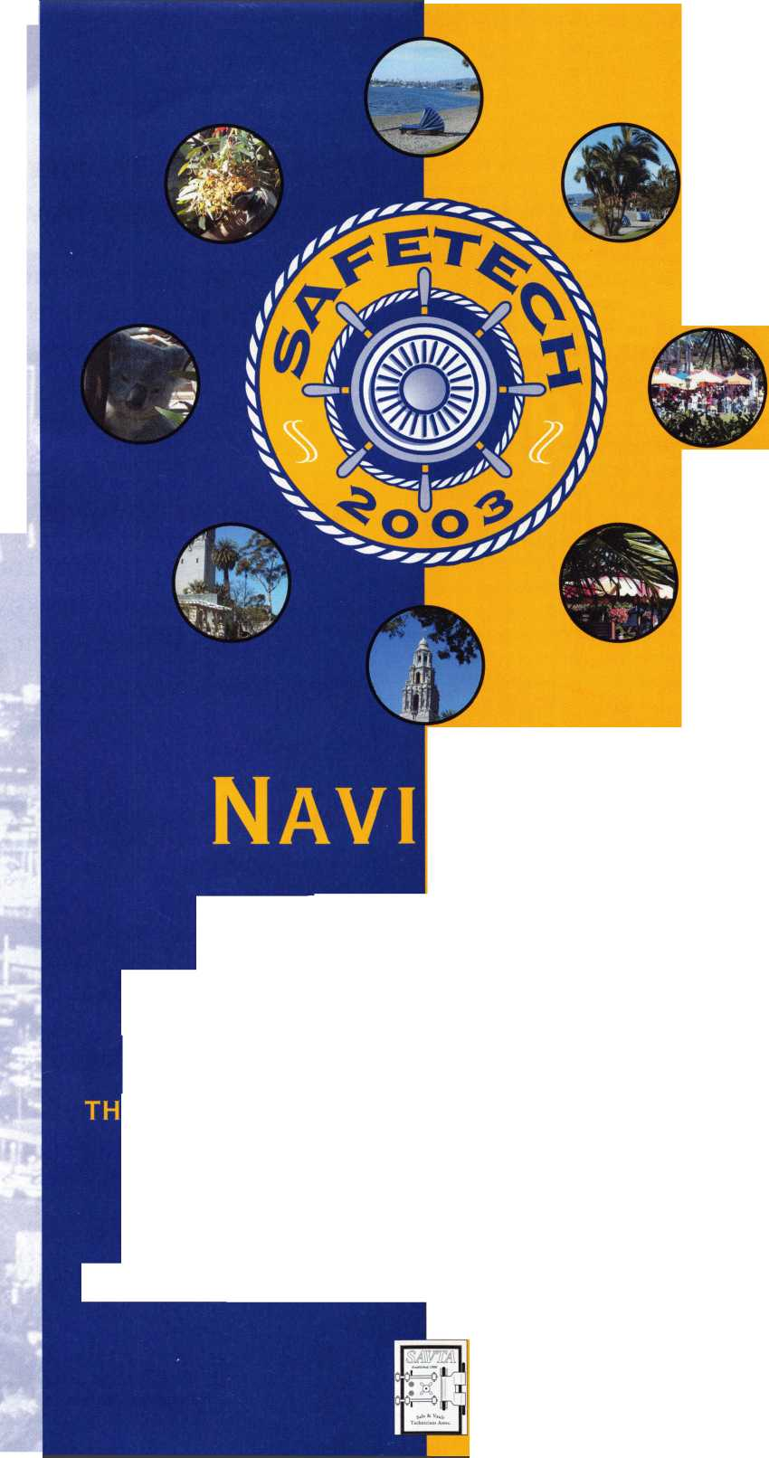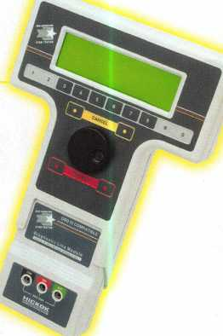

**You're never on**

**your own..**

**Toll Free Tech Support**

1-800-342-5080

**for more information visit**

**[www.hickok-inc.com](http://www.hickok-inc.com)**

Say "YES" to  
$100 phone calls

I've lost my Taurus

can you make a new

How much of your money  
have you sent to the

local Ford dealer?

8008LA New Generation STAR

Use the Ford factory tool to  
program transponder keys for  
ALL Ford/Mazda vehicles.

Keep the money in your pocket!

NGS

Complete

Ford/Mazda

transponder

coverage

PLUS the

ability to clear ALL

Diagnostic

Service Codes

